UNIVERSITI TEKNOLOGI MARA

TYPE YOUR THESIS TITLE

(MAX 8 LINES-PLEASE DELETE)

YOUR NAME

UiTM ID

Bachelor of Business Administration (Hons)

Finance

December 2018

UNIVERSITI TEKNOLOGI MARA

TYPE YOUR THESIS TITLE

(MAX 8 LINES)

Your Name

UiTm id

Final Year Project Paper submitted in fulfillment

of the requirements for the degree of

Bachelor of Business Administration

(Finance)

Faculty of Business and Management

**December 2018**

AUTHOR’S DECLARATION

I declare that the work in this final year project paper was carried out in accordance with the regulations of Universiti Teknologi MARA. It is original and is the results of my own work, unless otherwise indicated or acknowledged as referenced work. This thesis has not been submitted to any other academic institution or non-academic institution for any degree or qualification.

I, hereby, acknowledge that I have been supplied with the Academic Rules and Regulations for Undergraduate, Universiti Teknologi MARA, regulating the conduct of my study and research.

|  |  |  |
| --- | --- | --- |
| Name of Student | : | Abu bin Samah |
| Student I.D. No. | : | 2017000000 |
| Programme | : | Bachelor of Business and Administration (Hons) Finance. |
| Faculty | : | Business and Management |
| Thesis | : | Determinants of Foreign Exchange Movement in South East Asia. |
|  |  |  |
| Signature of Student | : | …………………………………………….. |
| Date | : | December 2018 |

ABSTRACT

The lack of management data and not knowing what level of park quality local authorities are trying to deliver is becoming a growing concern. The problem of urban landscape cannot be solved simply by providing more parks and spending more money on development and management. There is an urgent need for innovation, for better understanding of the current and potential role of the park to meet the needs in modern urban life. Thus, the adoption of a strategic approach is needed to planning and managing that urban landscape to carry out its function and roles. This research aim is to study the factors of park attributes that influence the development, planning and management of successful urban park in Kuala Muda. It specifically studies on Taman Tasik Cini as the sole representative of urban park in the context of Kuala Muda Structure Plan 2020. This research is based on data obtained from survey questionnaire that polled public attitudes regarding the factors of park attributes based on visitor’s perception and Harris’s (2008), park success factors. The data was analysed to evaluate and determine the park attributes and its level of preferences that influence the strategic approach to the planning and management of successful urban park. The research suggested that successful urban park as are linked to the physical and functional qualities of the park; security and comfort; visitors’ preferences and needs of the place. The results of the study also suggested that a holistic strategic approach is needed for the local authority to successfully managing the urban park. It is hope that the study can contribute to the improvement of urban park planning and management in Kuala Muda.

*--please delete--*

*Note:*

Maximum 250 words

*Limit to one (1) page only*

*No Paragraph*

*Font: Times New Roman - 12*

ACKNOWLEDGEMENT

Firstly, I wish to thank God for giving me the opportunity to embark on my PhD and for completing this long and challenging journey successfully. My gratitude and thanks go to my supervisor Assoc Prof Datuk.

My appreciation goes to the Captain and crewmembers of the MMC who provided the facilities and assistance during sampling. Special thanks to my colleagues and friends for helping me with this project.

Finally, this thesis is dedicated to the loving memory of my very dear late father and mother for the vision and determination to educate me. This piece of victory is dedicated to both of you. Alhamdulilah.

*--please delete--*

*Must include all supervisors names*

*Limit to one (1) page only*

*Font: Times New Roman - 12*

TABLE OF CONTENTS

|  |  |
| --- | --- |
|  | Page |

AUTHOR’S DECLARATION ii

ABSTRACT iii

ACKNOWLEDGEMENT iv

TABLE OF CONTENT v

LIST OF TABLES vii

LIST OF FIGURES viii

LIST OF PLATES ix

LIST OF SYMBOLS x

LIST OF ABBREVIATIONS xi

LIST OF NOMENCLATURE xii

CHAPTER One INTRODUCTION 1

1.1 Introduction 1

1.2 Research Background 1

1.3 Problem Statement 2

1.4 Research Questions 3

1.5 Research Objectives 3

1.6 Significance of the Study 3

1.7 Scope of the Study 5

1.8 Limitation of the Study 5

1.9 Definition of Key Terms 5

1.10 Summary 6

CHAPTER Two LITERATURE REVIEW 7

2.1 Introduction 7

2.2 Theory 7

2.3 Variable 1 8

2.4 Variable 2 10

2.5 Variable 3 10

2.6 Variable 4 11

2.7 Research Framework 11

2.8 Summary 11

CHAPTER Three RESEARCH METHODOLOGY 12

3.1 Introduction 12

3.2 Data Collection 12

3.3 Research Design 15

3.4 Hypotheses Statement 16

3.5 Research Methodology 17

3.6 Summary 17

CHAPTER Four RESULTS AND DISCUSSION 18

4.1 Introduction 18

4.2 Result 1 18

4.3 Result 2 18

4.4 Discussion 1 19

4.5 Discussion 2 19

4.6 Summary 19

CHAPTER Five CONCLUSION AND RECOMMENDATION 19

5.1 Introduction 20

5.2 Conclusion 1 20

5.3 Conclusion 2 20

5.4 Recommendation 1 20

5.5 Recommendation 2 20

5.6 Summary 21

REFERENCES 22

APPENDICES 23

LIST OF TABLES

| Tables | Title | Page |

Table 1.1 The Title for This Table is Here 1

Table 1.2 The Title for This Table is Here 2

Table 1.3 The Title for This Table is Here 2

Table 2.1 The Temperature Infomation 7

LIST OF FIGURES

|  |  |  |
| --- | --- | --- |
| Figures | Title | Page |

Figure 1.1 The Spectrum of Cooking Oil 4

Figure 3.1 Compressive strength of Rice Husk 13

Figure 3.2 Typical Steps Involved in QSAR Methodology 16

Figure 3.3 A Map Showing the Sampling Location in Islamabad, Pakistan 16

LIST OF PLATES

|  |  |  |
| --- | --- | --- |
| Plates | Title | Page |

Plate 1.1 A Picture of Light 4

Plate 2.1 A Sample of Grass and Bamboo 2 9

Plate 2.2 A Sample of Formatting Method 10

LIST OF SYMBOLS

|  |  |
| --- | --- |
| Symbols |  |
| A | Number of PLS or PCA components in the model and the number of selected latent variable in the model |
| a | Number of the PLS or PCA component |
| b | PLS regression coefficient |
| b | Number of blocks (b=1,2,3.....,K) |
| C | Coarse APM block |
|  | Pooled covariance matrix for the two classes |
|  | Covariance matrix for class g |
|  |  |
|  |  |
|  |  |
|  |  |
|  |  |

LIST OF ABBREVIATIONS

|  |  |
| --- | --- |
| Abbreviations |  |
| PCA | Principal Component Analysis |
|  |  |
|  |  |
|  |  |
|  |  |
|  |  |
|  |  |
|  |  |
|  |  |
|  |  |
|  |  |
|  |  |
|  |  |
|  |  |

LIST OF NOMENCLATURE

|  |  |
| --- | --- |
| Nomenclatures |  |
| A | Amplitude Ratio, (No Units) |
| C | Centroid of pipe, inches |
|  |  |
|  |  |
|  |  |
|  |  |
|  |  |
|  |  |
|  |  |
|  |  |
|  |  |
|  |  |
|  |  |
|  |  |
|  |  |

# INTRODUCTION

## Introduction

On the Insert tab, the galleries include items that are designed to coordinate with the overall look of your document. You can use these galleries to insert tables, headers, footers, lists, cover pages, and other document building blocks. When you create pictures, charts, or diagrams, they also coordinate with your current document look. You can easily change the formatting of selected.

Both the Themes gallery and the Quick Styles gallery provide reset commands so that you can always restore the look of your document to the original contained in your current template

## Research Background

On the Insert tab, the galleries include items that are designed to coordinate with the overall look of your document. You can use these galleries to insert tables, headers, footers, lists, cover pages, and other document building blocks. When you create pictures, charts, or diagrams, they also coordinate with your current document look. You can easily change the formatting of selected.

Both the Themes gallery and the Quick Styles gallery provide reset commands so that you can always restore the look of your document to the original contained in your current template.

Table 1.1   
The Title for This Table is Here

|  |  |  |
| --- | --- | --- |
| Title | Title | Title |
| To change the overall look of your document | To change the overall look of your document | To change the overall look of your document |
| Source: World Bank report 2016 | | |

Table 1.2   
The Title for This Table is Here

|  |  |  |  |  |
| --- | --- | --- | --- | --- |
| Batch | No of samples | Average per month | Percentage of LoD (Coarse APM) | Percentage of LoD (Fine APM) |
| 1 | 100 | 8 samples | 1.70% | 6.48% |
| 2 | 102 | 9 samples | 9.29% | 9.09% |
| 3 | 176 | 9 samples | 2.65% | 4.34% |

## Problem Statement

On the Insert tab, the galleries include items that are designed to coordinate with the overall look of your document. You can use these galleries to insert tables, headers, footers, lists, cover pages, and other document building blocks. When you create pictures, charts, or diagrams, they also coordinate with your current document look. You can easily change the formatting of selected.

Both the Themes gallery and the Quick Styles gallery provide reset commands so that you can always restore the look of your document to the original contained in your current template.

Table 1.3   
The Title for This Table is Here

|  |  |  |
| --- | --- | --- |
| Chemical C Composition | Surface Area (m2g-1) | Porosity (cm3g-1) |
| Neutral clay 0.68 0.68 | Neutral clay 0.68 0.68 | Neutral clay 0.68 0.68 |
| Bleaching clay | Bleaching clay | Bleaching clay |
| Note: Influence of the physical chemistry properties of an acid activated bentonite in the bleaching of olive oil. (Pradas et.al., 1993, p. 23) | | |

To make your document look professionally produced, Word provides header, footer, cover page, and text box designs that complement each other. For example, you can add a matching cover page, header, and sidebar. Click Insert and then choose the elements you want from the different galleries.Error! Reference source not found.On the Insert tab, the galleries include items that are designed to coordinate with the overall look of your document. You can use these galleries to insert tables, headers, footers, lists, cover pages, and other document building blocks. When you create pictures, charts, or diagrams, they also coordinate with your current document look You can easily change the formatting of selected.Error! Reference source not found.On the Insert tab, the galleries include items that are designed to coordinate with the overall look of your document. You can use these galleries to insert tables, headers, footers, lists, cover pages, and other document building blocks. When you create pictures, charts, or diagrams, they also coordinate with your current document look You can easily change the formatting of selected

## Research Questions

To make your document look professionally produced, Word provides header, footer, cover page, and text box designs that complement each other. For example, you can add a matching cover page, header, and sidebar. Click Insert and then choose the elements you want from the different galleries.

To perform data pre-processing and exploratory analysis by using PCA, SOMs and Class Separation Indices.

To analysis analysis Multiblock methods and regression analysis of environmental dataset.

## Research Objectives

To make your document look professionally produced, Word provides header, footer, cover page, and text box designs that complement each other. For example, you can add a matching cover page, header, and sidebar. Click Insert and then choose the elements you want from the different galleries.

To perform data pre-processing and exploratory analysis by using PCA, SOMs and Class Separation Indices.

To analysis analysis Multiblock methods and regression analysis of environmental dataset.

## Significance of the Study

You can easily change the formatting of selected text in the document text by choosing a look for the selected text from the Quick Styles gallery on the Home tab. You can also format text directly by using the other controls on the Home tab. Most controls offer a choice of using the look from the current theme or using a format that you specify directly. The sample of plates shown in Plate 1.1

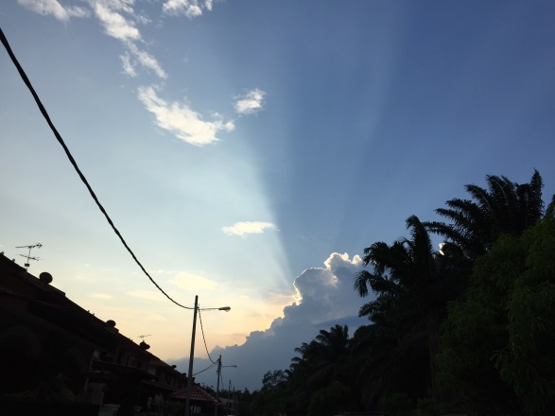

Plate 1.1 A Picture of Light

On the Insert tab, the galleries include items that are designed to coordinate with the overall look of your document. You can use these galleries to insert tables, headers, footers, lists, cover pages, and other document building blocks. When you create pictures, charts, or diagrams, they also coordinate with your current document look.



Figure 1.1 The Spectrum of Cooking Oil

#### Univariate Regression

On the Insert tab, the galleries include items that are designed to coordinate with the overall look of your document. You can use these galleries to insert tables, headers, footers, lists, cover pages, and other document building blocks. When you create pictures, charts, or diagrams, they also coordinate with your current document look.

#### Multivariate Regression

##### Principal Components Regression

When you create pictures, charts, or diagrams, they also coordinate with your current document look. You can easily change the formatting of selected text in the document text by choosing a look for the selected text from the Quick Styles gallery on the Home tab. You can also format text directly by using the other controls on the Home tab.

## Scope of the Study

You can easily change the formatting of selected text in the document text by choosing a look for the selected text from the Quick Styles gallery on the Home tab. You can also format text directly by using the other controls on the Home tab. Most controls offer a choice of using the look from the current theme or using a format that you specify directly.

## Limitation of the Study

You can easily change the formatting of selected text in the document text by choosing a look for the selected text from the Quick Styles gallery on the Home tab. You can also format text directly by using the other controls on the Home tab. Most controls offer a choice of using the look from the current theme or using a format that you specify directly.

## Definition of Key Terms

You can easily change the formatting of selected text in the document text by choosing a look for the selected text from the Quick Styles gallery on the Home tab. You can also format text directly by using the other controls on the Home tab. Most controls offer a choice of using the look from the current theme or using a format that you specify directly.

#### Univariate Regression

On the Insert tab, the galleries include items that are designed to coordinate with the overall look of your document. You can use these galleries to insert tables, headers, footers, lists, cover pages, and other document building blocks. When you create pictures, charts, or diagrams, they also coordinate with your current document look.

#### Multivariate Regression

##### Principal Components Regression

When you create pictures, charts, or diagrams, they also coordinate with your current document look. You can easily change the formatting of selected text in the document text by choosing a look for the selected text from the Quick Styles gallery on the Home tab. You can also format text directly by using the other controls on the Home tab.

## Summary

You can easily change the formatting of selected text in the document text by choosing a look for the selected text from the Quick Styles gallery on the Home tab. You can also format text directly by using the other controls on the Home tab. Most controls offer a choice of using the look from the current theme or using a format that you specify directly.

# LITERATURE REVIEW

## Introduction

You can easily change the formatting of selected text in the document text by choosing a look for the selected text from the Quick Styles gallery on the Home tab. You can also format text directly by using the other controls on the Home tab. Most controls offer a choice of using the look from the current theme or using a format that you specify directly. As shown in Table 2.1 and **Error! Reference source not found.**

Table 2.1   
The Temperature Infomation

|  |  |  |  |  |
| --- | --- | --- | --- | --- |
| Variable | Minimum | Maximum | Average | Standard deviation |
| Minimum temperature over 24 hours preceding 0300 GMT (0C) | 0.0 | 30.0 | 15.33 | 7.06 |
| Maximum temperature over 24 hours preceding 1200 GMT (0C) | 12.5 | 44.7 | 29.85 | 6.93 |

## Theory

You can easily change the formatting of selected text in the document text by choosing a look for the selected text from the Quick Styles gallery on the Home tab. You can also format text directly by using the other controls on the Home tab. Most controls offer a choice of using the look from the current theme or using a format that you specify directly.

To change the overall look of your document, choose new Theme elements on the Page Layout tab. To change the looks available in the Quick Style gallery, use the Change Current Quick Style Set command. Both the Themes gallery and the Quick Styles gallery provide reset commands so that you can always restore the look of your document to the original contained in your current template.

#### Theory 1

On the Insert tab, the galleries include items that are designed to coordinate with the overall look of your document. You can use these galleries to insert tables, headers, footers, lists, cover pages, and other document building blocks. When you create pictures, charts, or diagrams, they also coordinate with your current document look.

You can also format text directly by using the other controls on the Home tab. Most controls offer a choice of using the look from the current theme or using a format that you specify directly.

To change the overall look of your document, choose new Theme elements on the Page Layout tab. To change the looks available in the Quick Style gallery, use the Change Current Quick Style Set command. Both the Themes gallery and the Quick Styles gallery provide reset commands so that you can always restore the look of your document to the original contained in your current template.

#### Theory 2

To change the looks available in the Quick Style gallery, use the Change Current Quick Style Set command. Both the Themes gallery and the Quick Styles gallery provide reset commands so that you can always restore the look of your document to the original contained in your current template.

On the Insert tab, the galleries include items that are designed to coordinate with the overall look of your document. You can use these galleries to insert tables, headers, footers, lists, cover pages, and other document building blocks. When you create pictures, charts, or diagrams, they also coordinate with your current document look.

You can easily change the formatting of selected text in the document text by choosing a look for the selected text from the Quick Styles gallery on the Home tab. You can also format text directly by using the other controls on the Home tab. Most controls offer a choice of using the look from the current theme or using a format that you specify directly.

To change the overall look of your document, choose new Theme elements on the Page Layout tab. To change the looks available in the Quick Style gallery, use the Change Current Quick Style Set command. Both the Themes gallery and the Quick Styles gallery provide reset commands so that you can always restore the look of your

## Variable 1

On the Insert tab, the galleries include items that are designed to coordinate with the overall look of your document. You can use these galleries to insert tables, headers, footers, lists, cover pages, and other document building blocks. When you create pictures, charts, or diagrams, they also coordinate with your current document look.

You can easily change the formatting of selected text in the document text by choosing a look for the selected text from the Quick Styles gallery on the Home tab. You can also format text directly by using the other controls on the Home tab. Most controls offer a choice of using the look from the current theme or using a format that you specify directly.

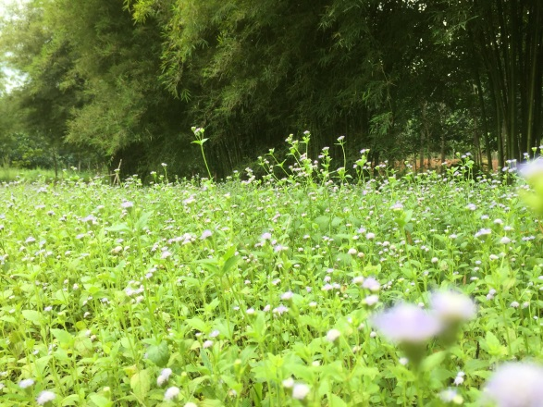

Plate 2.1 A Sample of Grass and Bamboo 2

To change the overall look of your document, choose new Theme elements on the Page Layout tab. To change the looks available in the Quick Style gallery, use the Change Current Quick Style Set command. Both the Themes gallery and the Quick Styles gallery provide reset commands so that you can always restore the look of your document to the original contained in your current template.

On the Insert tab, the galleries include items that are designed to coordinate with the overall look of your document. You can use these galleries to insert tables, headers, footers, lists, cover pages, and other document building blocks. When you create pictures, charts, or diagrams, they also coordinate with your current document look.

You can easily change the formatting of selected text in the document text by choosing a look for the selected text from the Quick Styles gallery on the Home tab. You can also format text directly by using the other controls on the Home tab. Most controls offer a choice of using the look from the current theme or using a format that you specify directly.

To change the overall look of your document, choose new Theme elements on the Page Layout tab. To change the looks available in the Quick Style gallery, use the Change Current Quick Style Set command. Both the Themes gallery and the Quick Styles gallery provide reset commands so that you can always restore the look of your document to the original contained in your current template.

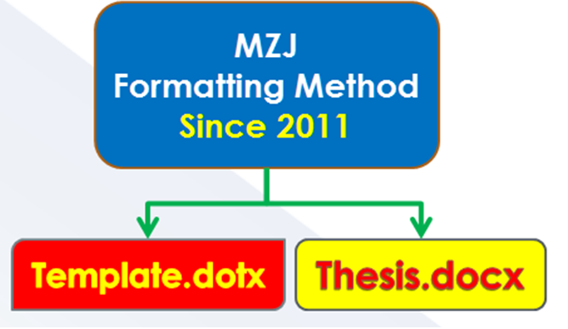

Plate 2.2 A Sample of Formatting Method

## Variable 2

On the Insert tab, the galleries include items that are designed to coordinate with the overall look of your document. You can use these galleries to insert tables, headers, footers, lists, cover pages, and other document building blocks. When you create pictures, charts, or diagrams, they also coordinate with your current document look.

You can easily change the formatting of selected text in the document text by choosing a look for the selected text from the Quick Styles gallery on the Home tab. You can also format text directly by using the other controls on the Home tab. Most controls offer a choice of using the look from the current theme or using a format that you specify directly.

## Variable 3

On the Insert tab, the galleries include items that are designed to coordinate with the overall look of your document. You can use these galleries to insert tables, headers, footers, lists, cover pages, and other document building blocks. When you create pictures, charts, or diagrams, they also coordinate with your current document look.

You can easily change the formatting of selected text in the document text by choosing a look for the selected text from the Quick Styles gallery on the Home tab. You can also format text directly by using the other controls on the Home tab. Most controls offer a choice of using the look from the current theme or using a format that you specify directly.

## Variable 4

On the Insert tab, the galleries include items that are designed to coordinate with the overall look of your document. You can use these galleries to insert tables, headers, footers, lists, cover pages, and other document building blocks. When you create pictures, charts, or diagrams, they also coordinate with your current document look.

You can easily change the formatting of selected text in the document text by choosing a look for the selected text from the Quick Styles gallery on the Home tab. You can also format text directly by using the other controls on the Home tab. Most controls offer a choice of using the look from the current theme or using a format that you specify directly.

## Research Framework

On the Insert tab, the galleries include items that are designed to coordinate with the overall look of your document. You can use these galleries to insert tables, headers, footers, lists, cover pages, and other document building blocks. When you create pictures, charts, or diagrams, they also coordinate with your current document look.

You can easily change the formatting of selected text in the document text by choosing a look for the selected text from the Quick Styles gallery on the Home tab. You can also format text directly by using the other controls on the Home tab. Most controls offer a choice of using the look from the current theme or using a format that you specify directly.

## Summary

On the Insert tab, the galleries include items that are designed to coordinate with the overall look of your document. You can use these galleries to insert tables, headers, footers, lists, cover pages, and other document building blocks. When you create pictures, charts, or diagrams, they also coordinate with your current document look.

# RESEARCH METHODOLOGY

## Introduction

On the Insert tab, the galleries include items that are designed to coordinate with the overall look of your document. You can use these galleries to insert tables, headers, footers, lists, cover pages, and other document building blocks. When you create pictures, charts, or diagrams, they also coordinate with your current document look.

## Data Collection

(Normal UiTM Paragraph 1)On the Insert tab, the galleries include items that are designed to coordinate with the overall look of your document. You can use these galleries to insert table. When you create pictures, charts, or diagrams, they also coordinate with your current document look.

(Normal UiTM Paragraph 2b) To change the overall look of your document, choose new Theme elements on the Page Layout tab. To change the looks available in the Quick Style gallery, use the Change Current Quick Style Set command. Both the Themes gallery and the Quick Styles gallery provide reset commands so that you can always restore the look of your document to the original contained in your current template.

On the Insert tab, the galleries include items that are designed to coordinate with the overall look of your document. You can use these galleries to insert tables, headers, footers, lists, cover pages, and other document building blocks. When you create pictures, charts, or diagrams, they also coordinate with your current document look. You can easily change the formatting of selected text in the document text by choosing a look for the selected text from the Quick Styles gallery on the Home tab.

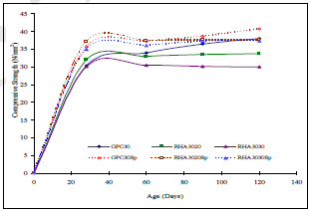

Figure 3.1 Compressive strength of Rice Husk

#### Data 1

On the Insert tab, the galleries include items that are designed to coordinate with the overall look of your document. You can use these galleries to insert tables, headers, footers, lists, cover pages, and other document building blocks. When you create pictures, charts, or diagrams, they also coordinate with your current document look The sample for writing an equation are shown at (3.1and (3.2);

|  |  |
| --- | --- |
|  | (3.1) |
|  | (3.2) |

To change the overall look of your document, choose new Theme elements on the Page Layout tab. To change the looks available in the Quick Style gallery, use the Change Current Quick Style Set command. Both the Themes gallery and the Quick Styles gallery provide reset commands so that you can always restore the look of your document to the original contained in your current template. On The Insert Tab, The Galleries Include Items That Are Designed To Coordinate With The Overall Look Of Your Document.

Save time in Word with new buttons that show up where you need them. To change the way a picture fits in your document, click it and a button for layout options appears next to it. When you work on a table, click where you want to add a row or a column, and then click the plus sign.

Reading is easier, too, in the new Reading view. You can collapse parts of the document and focus on the text you want. If you need to stop reading before you reach the end, Word remembers where you left off - even on another device.

#### Data 2

To change the overall look of your document, choose new Theme elements on the Page Layout tab. To change the looks available in the Quick Style gallery, use the Change Current Quick Style Set command. Both the Themes gallery and the Quick Styles gallery provide reset commands so that you can always restore the look of your document to the original contained in your current template.nYou Can Use These Galleries To Insert Tables, Headers, Footers, Lists, Cover Pages, And Other Document Building Blocks.

When you create pictures, charts, or diagrams, they also coordinate with your current document look. You can easily change the formatting of selected text in the document text by choosing a look for the selected text from the Quick Styles gallery on the Home tab.

You can also format text directly by using the other controls on the Home tab. Most controls offer a choice of using the look from the current theme or using a format that you specify directly.

#### Data 3

On the Insert tab, the galleries include items that are designed to coordinate with the overall look of your document. You can use these galleries to insert tables, headers, footers, lists, cover pages, and other document building blocks. When you create pictures, charts, or diagrams, they also coordinate with your current document look.

“You can easily change the formatting of selected text in the document text by choosing a look for the selected text from the Quick Styles gallery on the Home tab. You can also format text directly by using the other controls on the Home tab. Most controls offer a choice of using the look from the current theme or using a format that you specify directly.”

To change the overall look of your document, choose new Theme elements on the Page Layout tab. To change the looks available in the Quick Style gallery, use the Change Current Quick Style Set command. Both the Themes gallery and the Quick Styles gallery provide reset commands so that you can always restore the look of your document to the original contained in your current template.

On the Insert tab, the galleries include items that are designed to coordinate with the overall look of your document. You can use these galleries to insert tables, headers, footers, lists, cover pages, and other document building blocks. When you create pictures, charts, or diagrams, they also coordinate with your current document look.

## Research Design

On the Insert tab, the galleries include items that are designed to coordinate with the overall look of your document. You can use these galleries to insert tables, headers, footers, lists, cover pages, and other document building blocks. When you create pictures, charts, or diagrams, they also coordinate with your current document look.

You can easily change the formatting of selected text in the document text by choosing a look for the selected text from the Quick Styles gallery on the Home tab. You can also format text directly by using the other controls on the Home tab. Most controls offer a choice of using the look from the current theme or using a format that you specify directly.

To change the overall look of your document, choose new Theme elements on the Page Layout tab. To change the looks available in the Quick Style gallery, use the Change Current Quick Style Set command. Both the Themes gallery and the Quick Styles gallery provide reset commands so that you can always restore the look of your document to the original contained in your current template.

On the Insert tab, the galleries include items that are designed to coordinate with the overall look of your document. You can use these galleries to insert tables, headers, footers, lists, cover pages, and other document building blocks. When you create pictures, charts, or diagrams, they also coordinate with your current document look.

You can easily change the formatting of selected text in the document text by choosing a look for the selected text from the Quick Styles gallery on the Home tab. You can also format text directly by using the other controls on the Home tab. Most controls offer a choice of using the look from the current theme or using a format that you specify directly.

Figure 3.2 Typical Steps Involved in QSAR Methodology

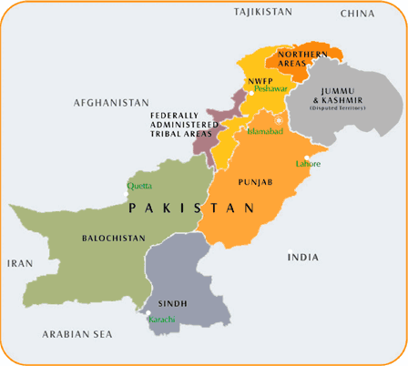

Nilore

Figure 3.3 A Map Showing the Sampling Location in Islamabad, Pakistan

To change the overall look of your document, choose new Theme elements on the Page Layout tab. To change the looks available in the Quick Style gallery, use the Change Current Quick Style Set command. Both the Themes gallery and the Quick Styles gallery provide reset commands so that you can always restore the look of your document to the original contained in your current template.

## Hypotheses Statement

On the Insert tab, the galleries include items that are designed to coordinate with the overall look of your document. You can use these galleries to insert tables, headers, footers, lists, cover pages, and other document building blocks. When you create pictures, charts, or diagrams, they also coordinate with your current document look.

You can easily change the formatting of selected text in the document text by choosing a look for the selected text from the Quick Styles gallery on the Home tab. You can also format text directly by using the other controls on the Home tab. Most controls offer a choice of using the look from the current theme or using a format that you specify directly.To change the overall look of your document, choose new Theme elements on the Page Layout tab. the look of your document to the original contained in your current template.

## Research Methodology

On the Insert tab, the galleries include items that are designed to coordinate with the overall look of your document. You can use these galleries to insert tables, headers, footers, lists, cover pages, and other document building blocks. When you create pictures, charts, or diagrams, they also coordinate with your current document look.

## Summary

On the Insert tab, the galleries include items that are designed to coordinate with the overall look of your document. You can use these galleries to insert tables, headers, footers, lists, cover pages, and other document building blocks. When you create pictures, charts, or diagrams, they also coordinate with your current document look.

# RESULTS AND DISCUSSION

## Introduction

On the Insert tab, the galleries include items that are designed to coordinate with the overall look of your document. You can use these galleries to insert tables, headers, footers, lists, cover pages, and other document building blocks. When you create pictures, charts, or diagrams, they also coordinate with your current document look.(Abbas et al., 2011)

On the Insert tab, the galleries include items that are designed to coordinate with the overall look of your document.

You can use these galleries to insert tables, headers, footers, lists, cover pages, and other document building blocks.

When you create pictures, charts, or diagrams, they also coordinate with your current document look.

You can easily change the formatting of selected text in the document text by choosing a look for the selected text from the Quick Styles gallery on the Home tab.

You can also format text directly by using the other controls on the Home tab.

## Result 1

You can easily change the formatting of selected text in the document text by choosing a look for the selected text from the Quick Styles gallery on the Home tab. You can also format text directly by using the other controls on the Home tab. Most controls offer a choice of using the look from the current theme or using a format that you specify directly.(2010a; 2010b; 2013)

## Result 2

You can easily change the formatting of selected text in the document text by choosing a look for the selected text from the Quick Styles gallery on the Home tab. You can also format text directly by using the other controls on the Home tab. Most controls offer a choice of using the look from the current theme or using a format that you specify directly.(2010a; 2010b; 2013)

## Discussion 1

To change the overall look of your document, choose new Theme elements on the Page Layout tab. To change the looks available in the Quick Style gallery, use the Change Current Quick Style Set command. Both the Themes gallery and the Quick Styles gallery provide reset commands so that you can always restore the look of your document to the original contained in your current template.(Mohd Zuli Jaafar et al., 2006; Mohd Z Jaafar et al., 2011; Lazim et al., 2013; Sim et al., 2015)

## Discussion 2

To change the overall look of your document, choose new Theme elements on the Page Layout tab. To change the looks available in the Quick Style gallery, use the Change Current Quick Style Set command. Both the Themes gallery and the Quick Styles gallery provide reset commands so that you can always restore the look of your document to the original contained in your current template.(Mohd Zuli Jaafar et al., 2006; Mohd Z Jaafar et al., 2011; Lazim et al., 2013; Sim et al., 2015)

## Summary

To change the overall look of your document, choose new Theme elements on the Page Layout tab. To change the looks available in the Quick Style gallery, use the Change Current Quick Style Set command. Both the Themes gallery and the Quick Styles gallery provide reset commands so that you can always restore the look of your document to the original contained in your current template.(Mohd Zuli Jaafar et al., 2006; Mohd Z Jaafar et al., 2011; Lazim et al., 2013; Sim et al., 2015)

# CONCLUSION AND RECOMMENDATION

## Introduction

On the Insert tab, the galleries include items that are designed to coordinate with the overall look of your document. You can use these galleries to insert tables, headers, footers, lists, cover pages, and other document building blocks. When you create pictures, charts, or diagrams, they also coordinate with your current document look.(Abbas et al., 2011)

## Conclusion 1

On the Insert tab, the galleries include items that are designed to coordinate with the overall look of your document. You can use these galleries to insert tables, headers, footers, lists, cover pages, and other document building blocks. When you create pictures, charts, or diagrams, they also coordinate with your current document look.(Abbas et al., 2011)

## Conclusion 2

On the Insert tab, the galleries include items that are designed to coordinate with the overall look of your document. You can use these galleries to insert tables, headers, footers, lists, cover pages, and other document building blocks. When you create pictures, charts, or diagrams, they also coordinate with your current document look.(Abbas et al., 2011)

## Recommendation 1

On the Insert tab, the galleries include items that are designed to coordinate with the overall look of your document. You can use these galleries to insert tables, headers, footers, lists, cover pages, and other document building blocks. When you create pictures, charts, or diagrams, they also coordinate with your current document look.(Abbas et al., 2011)

## Recommendation 2

On the Insert tab, the galleries include items that are designed to coordinate with the overall look of your document. You can use these galleries to insert tables, headers, footers, lists, cover pages, and other document building blocks. When you create pictures, charts, or diagrams, they also coordinate with your current document look.(Abbas et al., 2011)

## Summary

On the Insert tab, the galleries include items that are designed to coordinate with the overall look of your document. You can use these galleries to insert tables, headers, footers, lists, cover pages, and other document building blocks. When you create pictures, charts, or diagrams, they also coordinate with your current document look.(Abbas et al., 2011)

REFERENCES

Abbas, M., Shehab, A. A.-M., Hassan, N., & Al-Samuraee, A. (2011). Effect of temperature and deposition time on the optical properties of chemically deposited nanostructure PbS thin films. Thin Solid Films, 519(15), 4917-4922.

Abdulgafour, H., Hassan, Z., Al-Hardan, N., & Yam, F. (2010a). Growth of high-quality ZnO nanowires without a catalyst. Physica B: Condensed Matter, 405(19), 4216-4218.

Abdulgafour, H., Hassan, Z., Al-Hardan, N., & Yam, F. (2010b). Growth of zinc oxide nanoflowers by thermal evaporation method. Physica B: Condensed Matter, 405(11), 2570-2572.

Abdulgafour, H., Hassan, Z., Yam, F., & Chin, C. (2013). Sensing devices based on ZnO hexagonal tube-like nanostructures grown on p-GaN heterojunction by wet thermal evaporation. Thin Solid Films, 540, 212-220.

Jaafar, M. Z., Hasan, M. N., & Wong, T. W. (2006). Quantitative structure-activity relationships of peroxisome proliferator activated receptor Y agonist.

Jaafar, M. Z., Khan, A. H., Adnan, S., Markwitz, A., Siddique, N., Waheed, S., et al. (2011). Multiblock analysis of environmental measurements: A case study of using Proton Induced X-ray Emission and meteorology dataset obtained from Islamabad Pakistan. Chemometrics and Intelligent Laboratory Systems, 107(1), 31-43.

Lazim, A. M., Jaafar, M. Z., Phang Wei Shong, P., & Jamil, S. (2013). Determination of Commercials Cooking Oils and Fats Using Chemometrics Methods.

Sim, S., Ling, T., Lau, S., & Jaafar, M. (2015). A novel computer-aided multivariate water quality index. Environmental Monitoring and Assessment, 187(4), 1-11.

APPENDICES

APPENDIX 1

Example of the Codes in PLS Algorithms

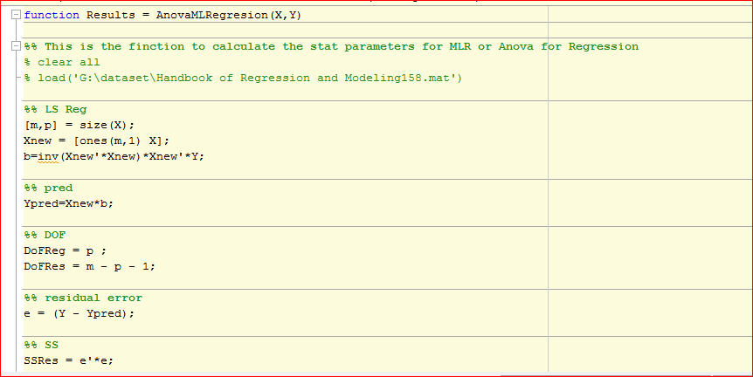

APPENDIX 2

Table of Parameters Used in Data Processing for PLS Testing Precuders on the Classification of Biological Activity

|  |  |  |
| --- | --- | --- |
| Type | Formula | Description |
| C1 |  | Mean centring |
| C2 |  | Standardisation |
| C3 |  | Range scaling |