FORMATTING STYLE WITHIN PARAGRAPH
Open Word document
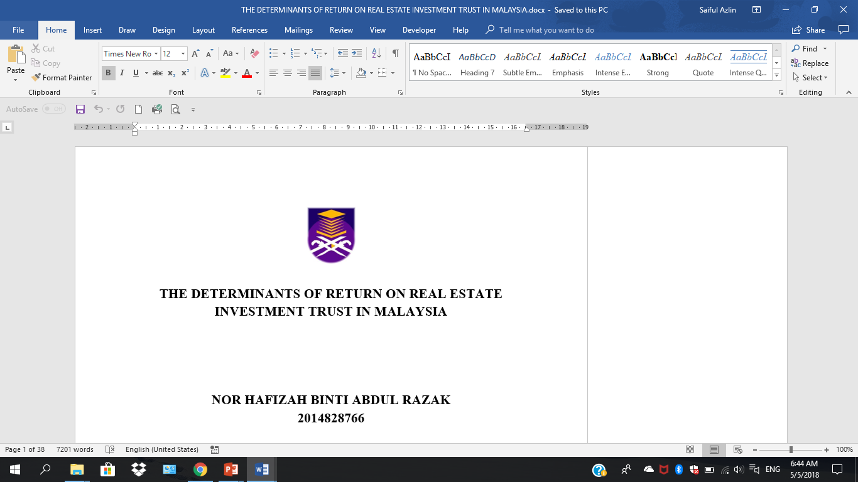

Click File
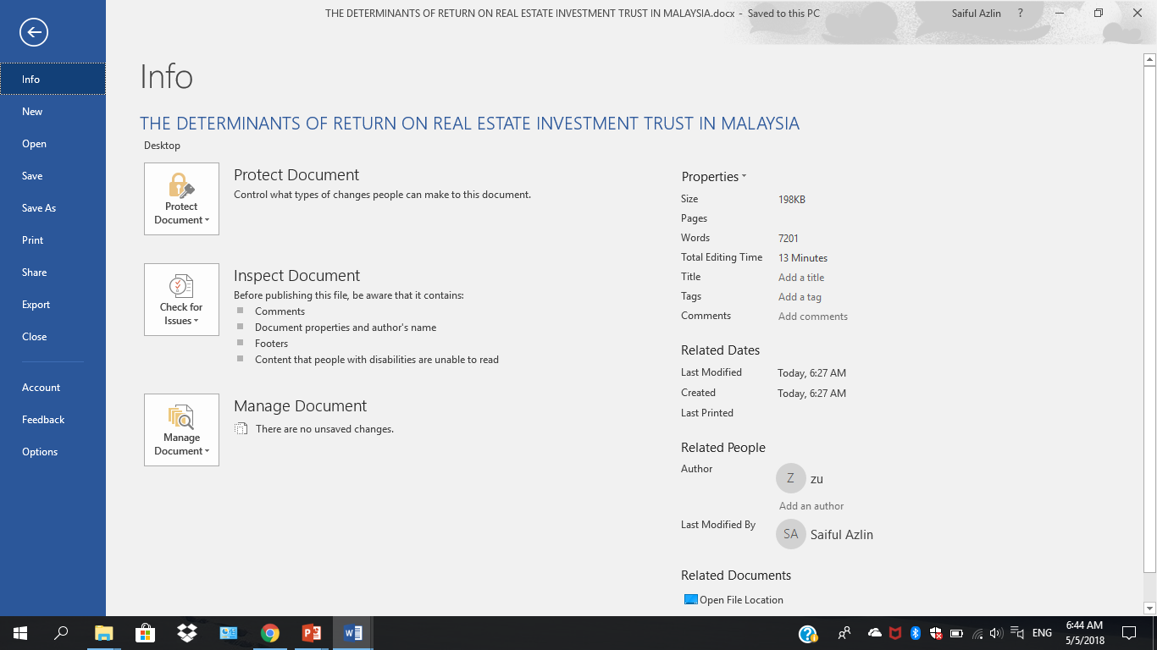

Click Options
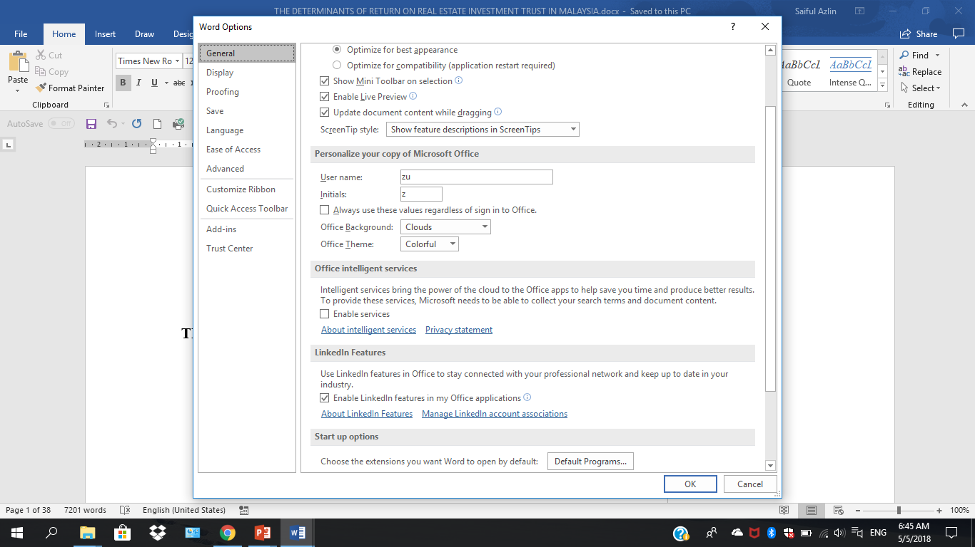

Choose Customize Ribbon
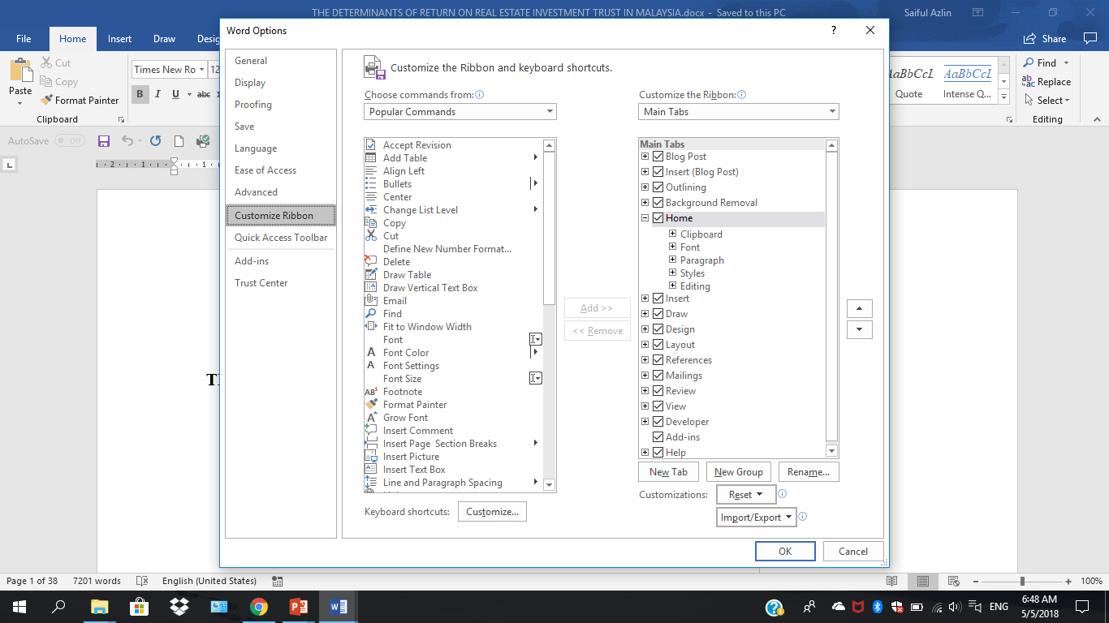
Tick Developer

Without Developer
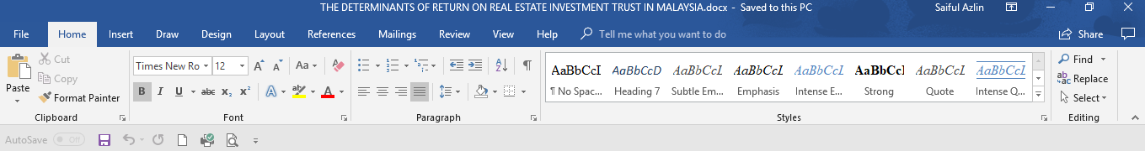
With Developer
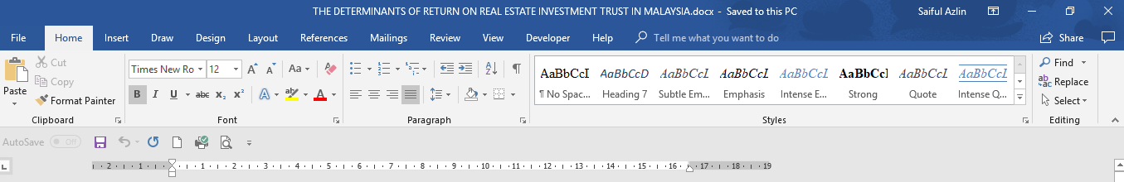

Open your document
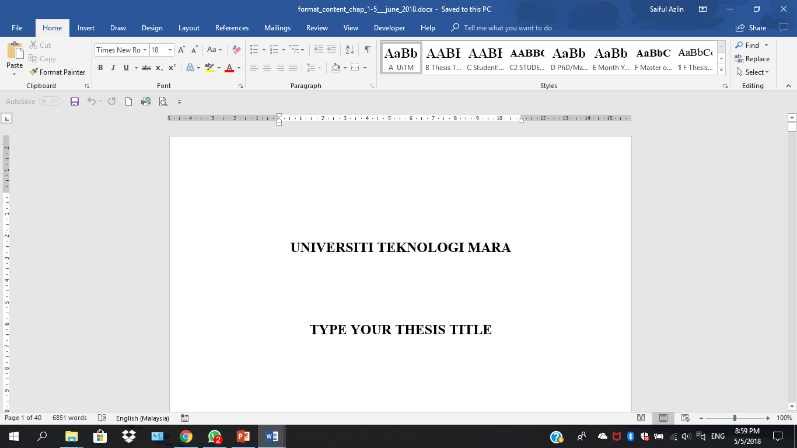
Choose Developer
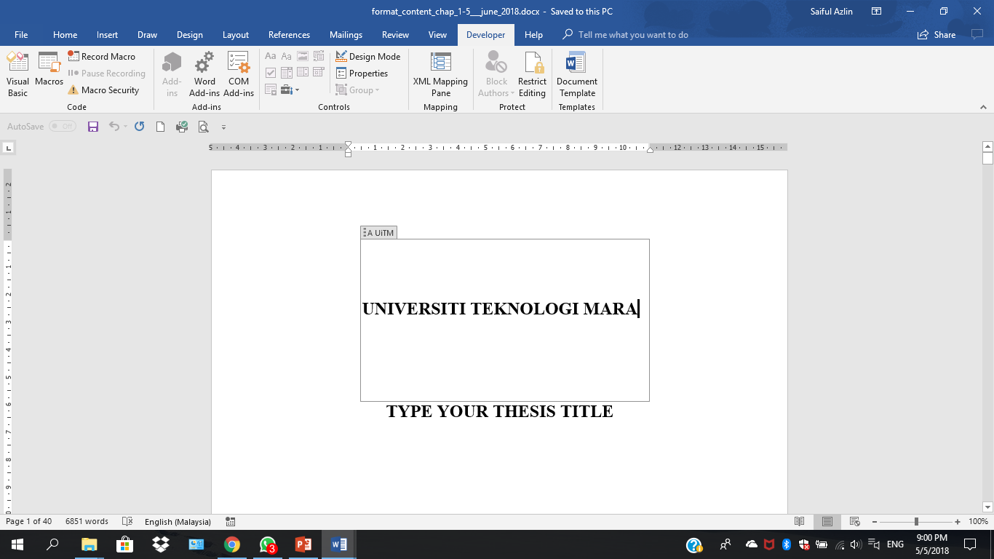

Click Document Template
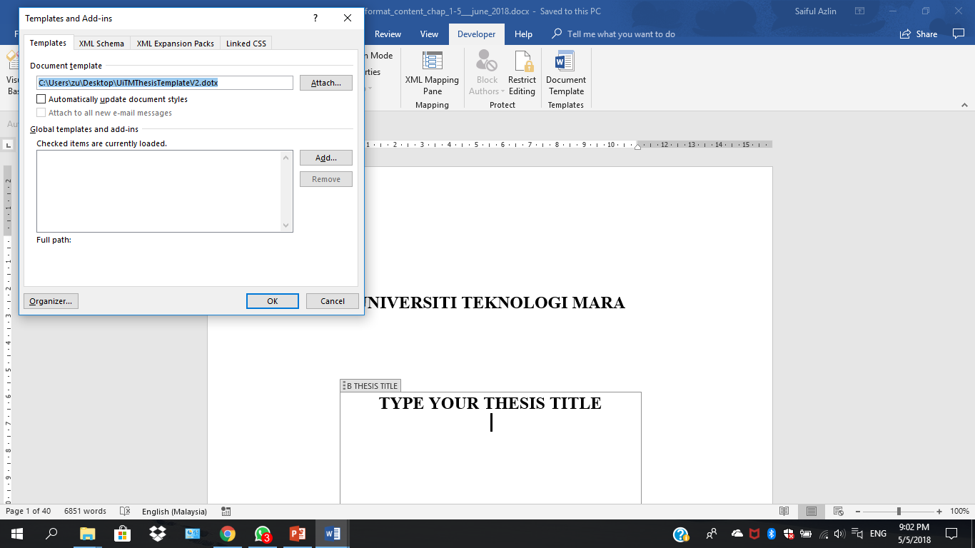

Click Attach—UiTMThesisTemplateV2 and tick Automatically update document style
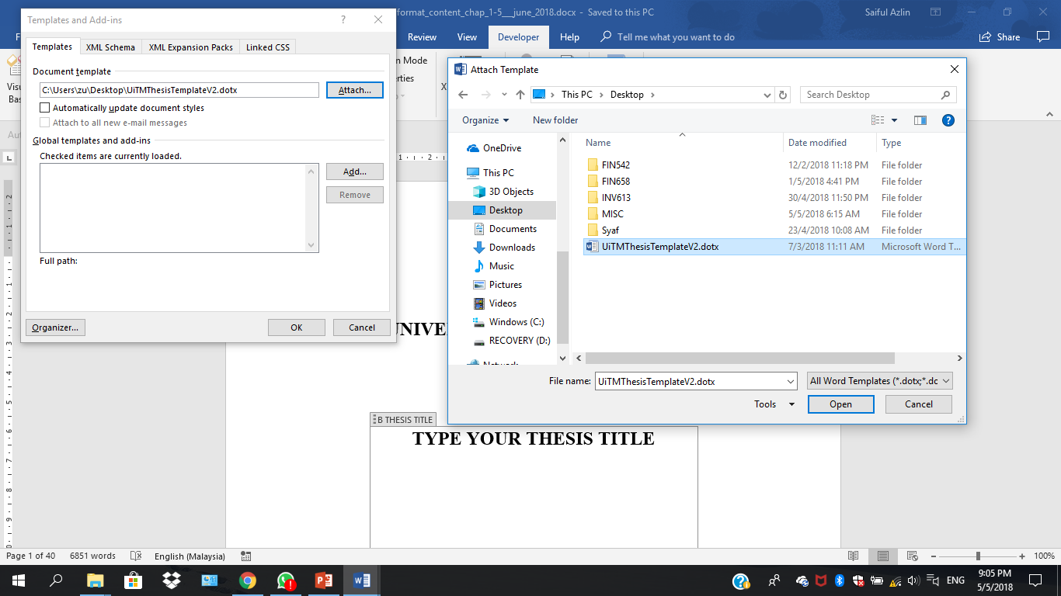

Go Home and click on the arrow at the bottom corner right of Styles
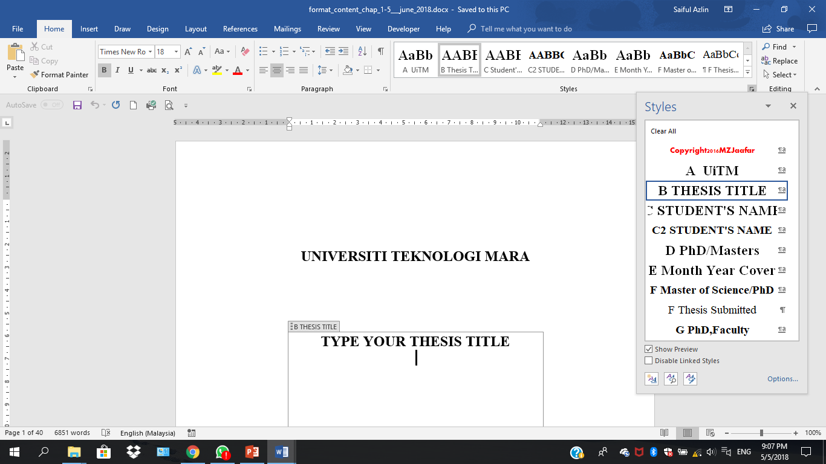

Put the cursor in the middle of the paragraph and choose the appropriate style according to the format given in the blog
Before reformatting
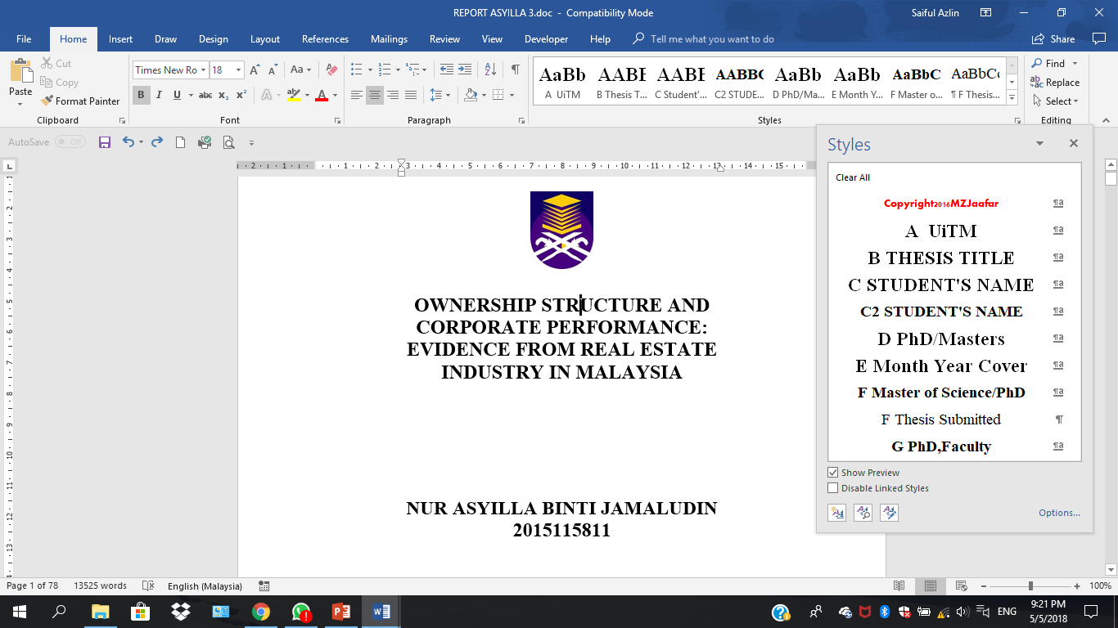

After reformatting thesis title
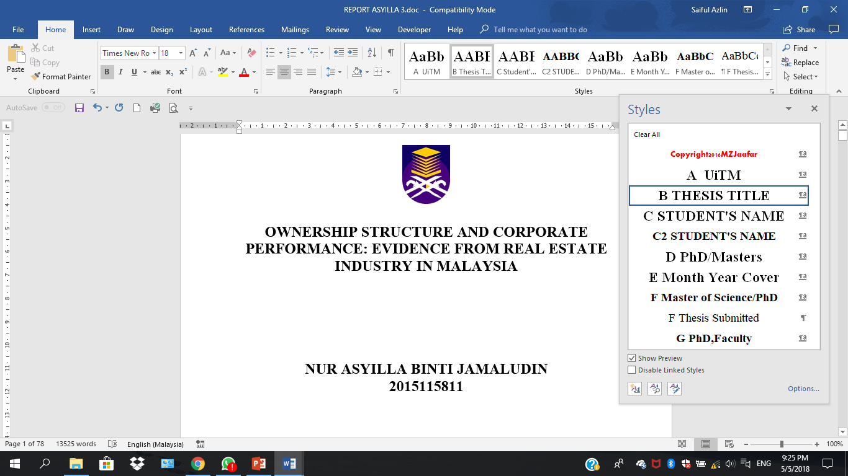

After reformatting Student’s Name
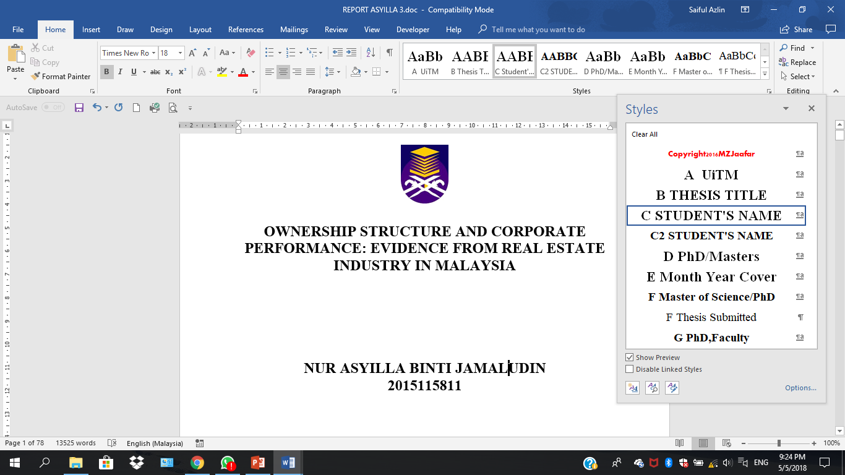

Before reformatting sub-title and paragraph
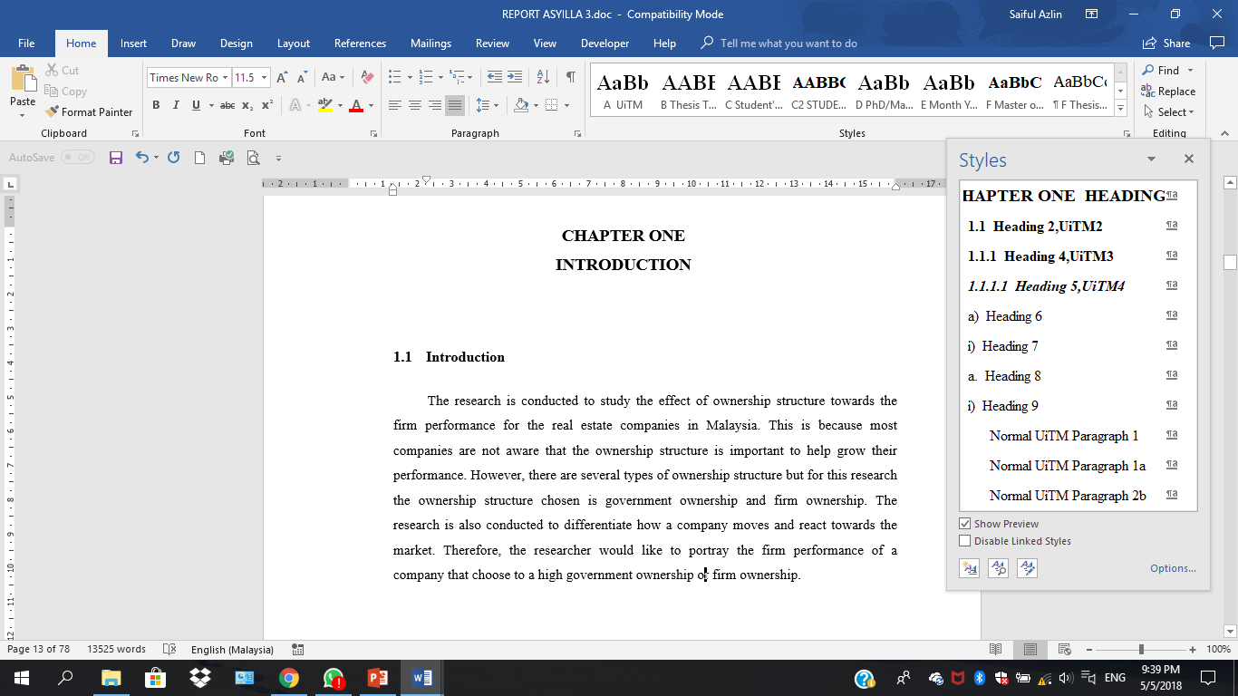

After reformatting sub-title and paragraph
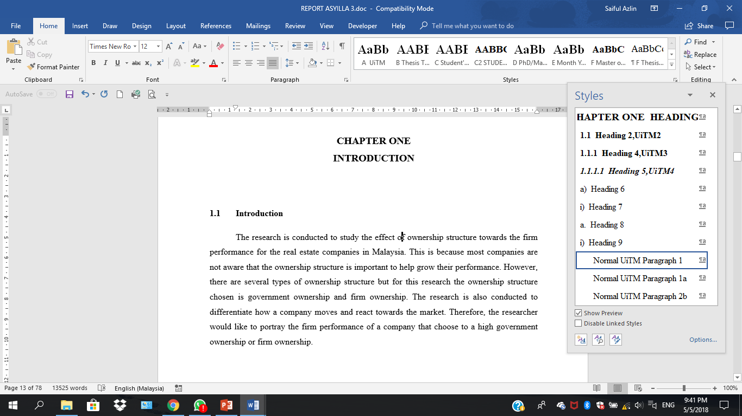

May also ‘clear all formatting’ and click on respective style
After clear all formatting
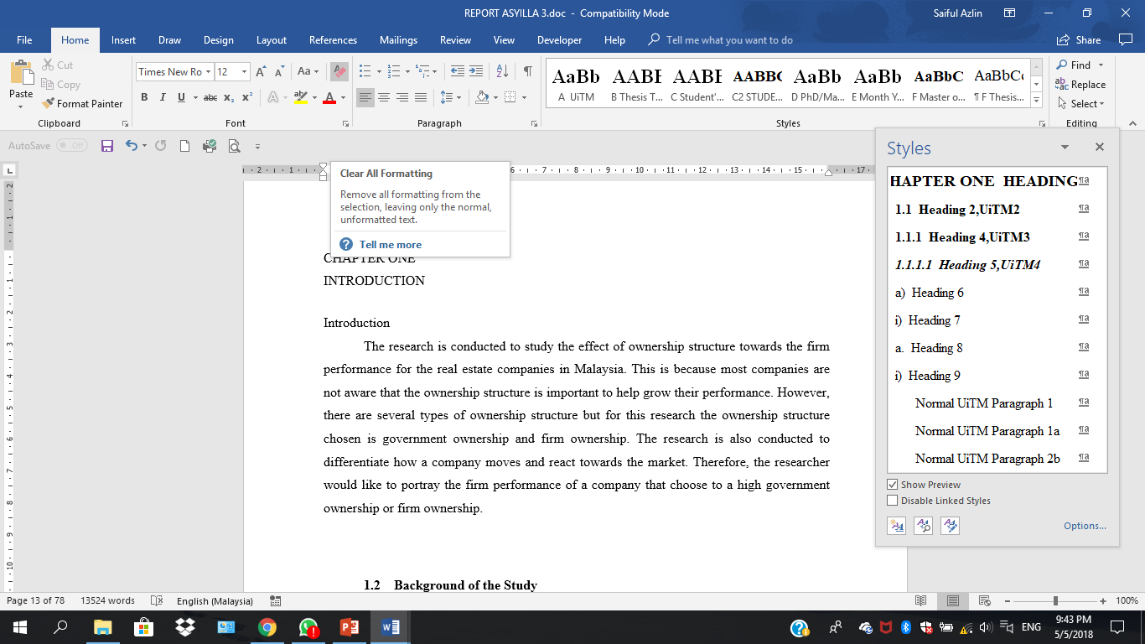

Table before formatting
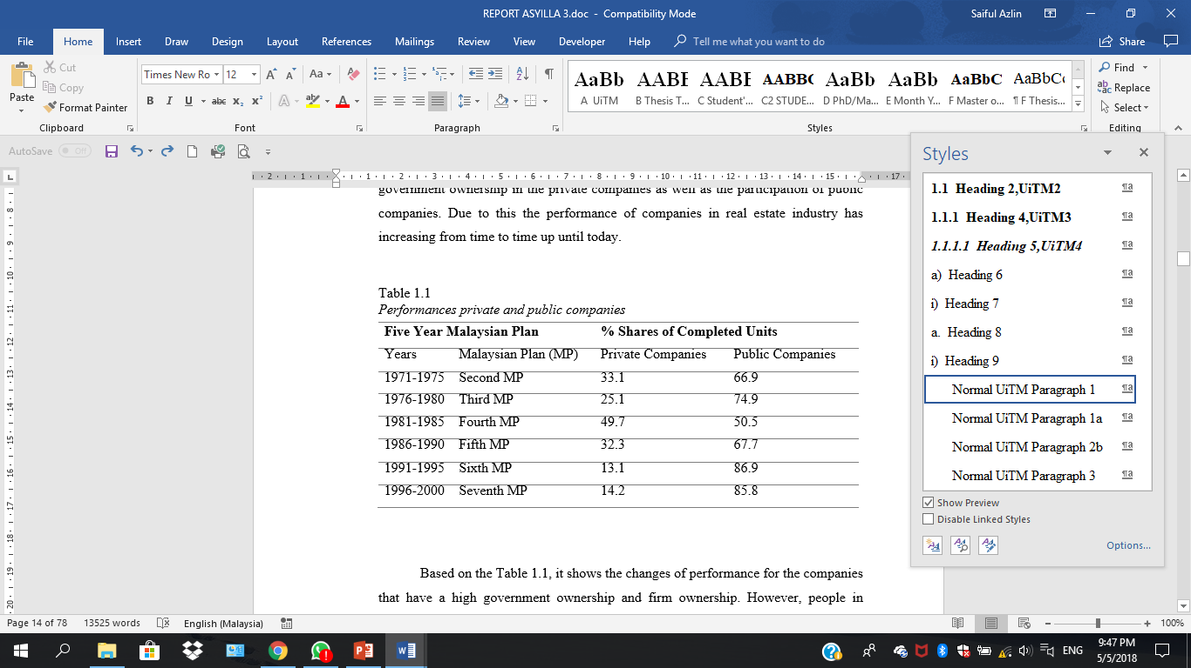

Table after formatting
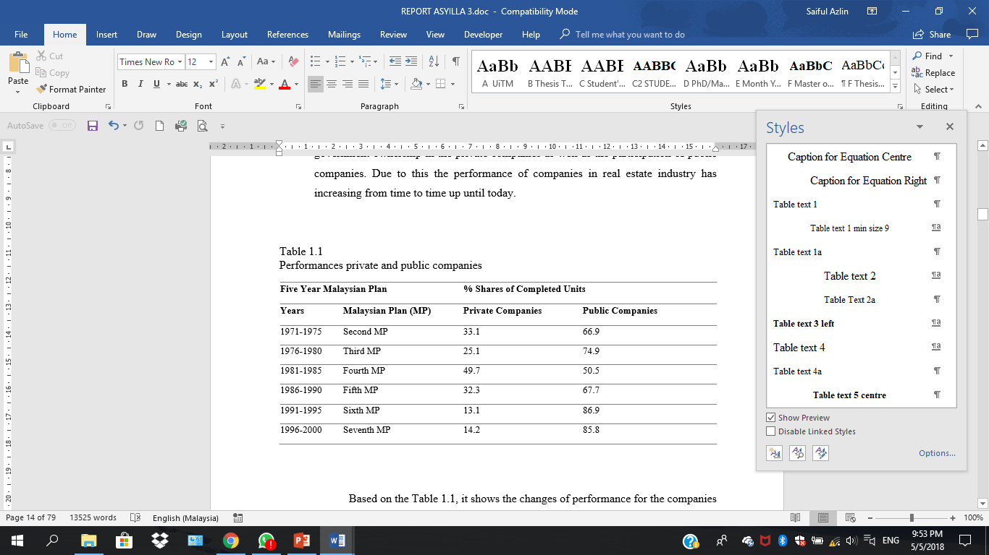

FORMATTING SPACE BETWEEN PARAGRAPH
Click File and choose option

Click Advanced
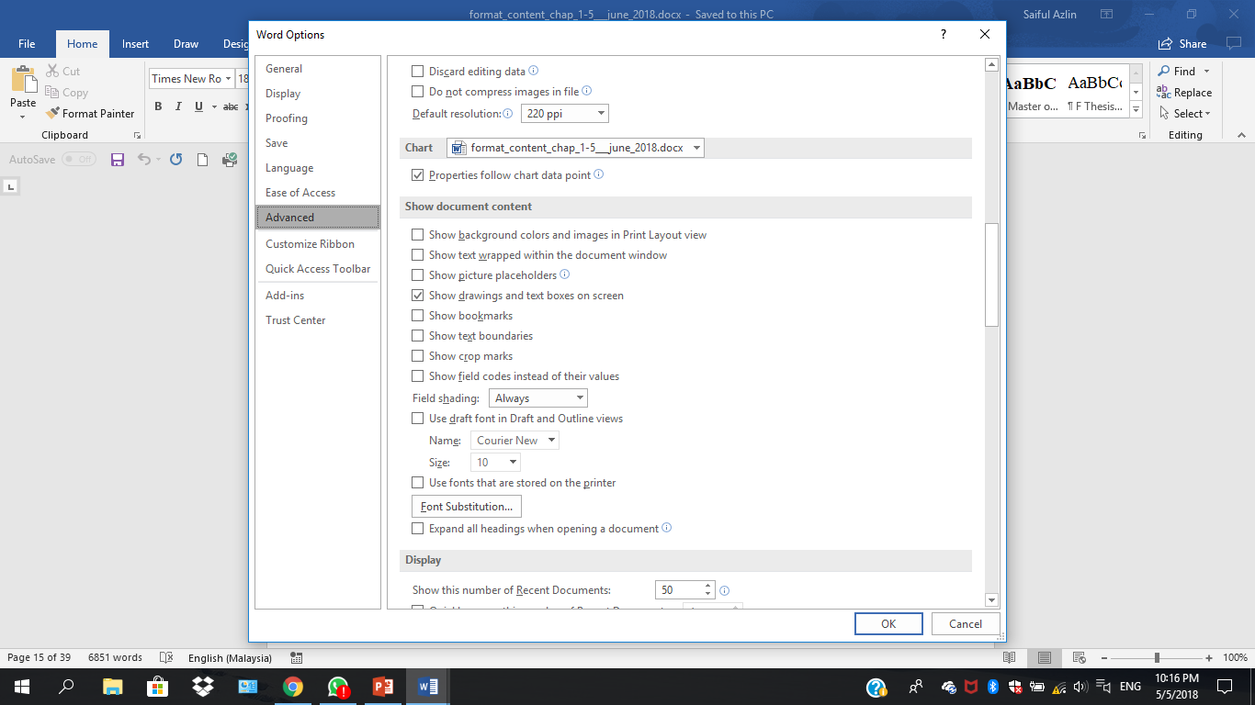
Find show document content and tick show text boundaries

Text boundaries was unticked
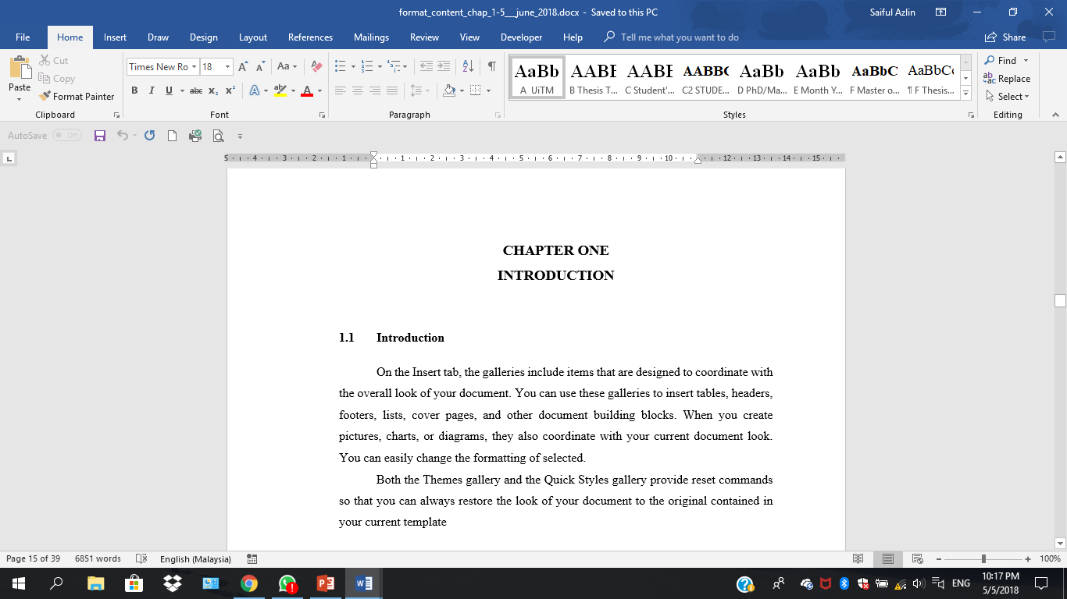

Text boundaries was ticked
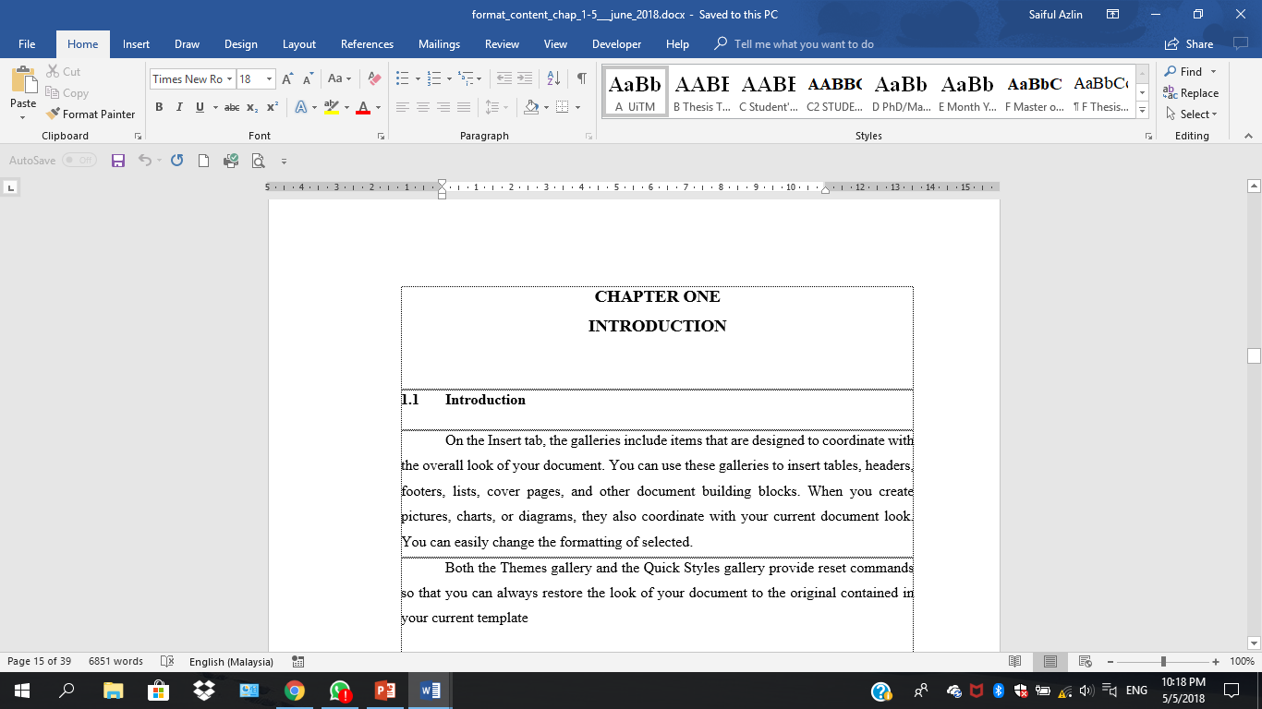

May also use paragraph marks
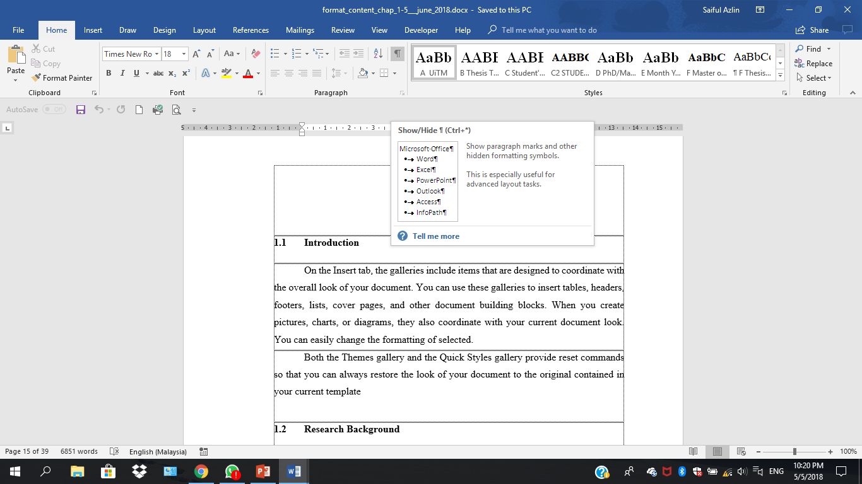

Paragraph marks was ticked
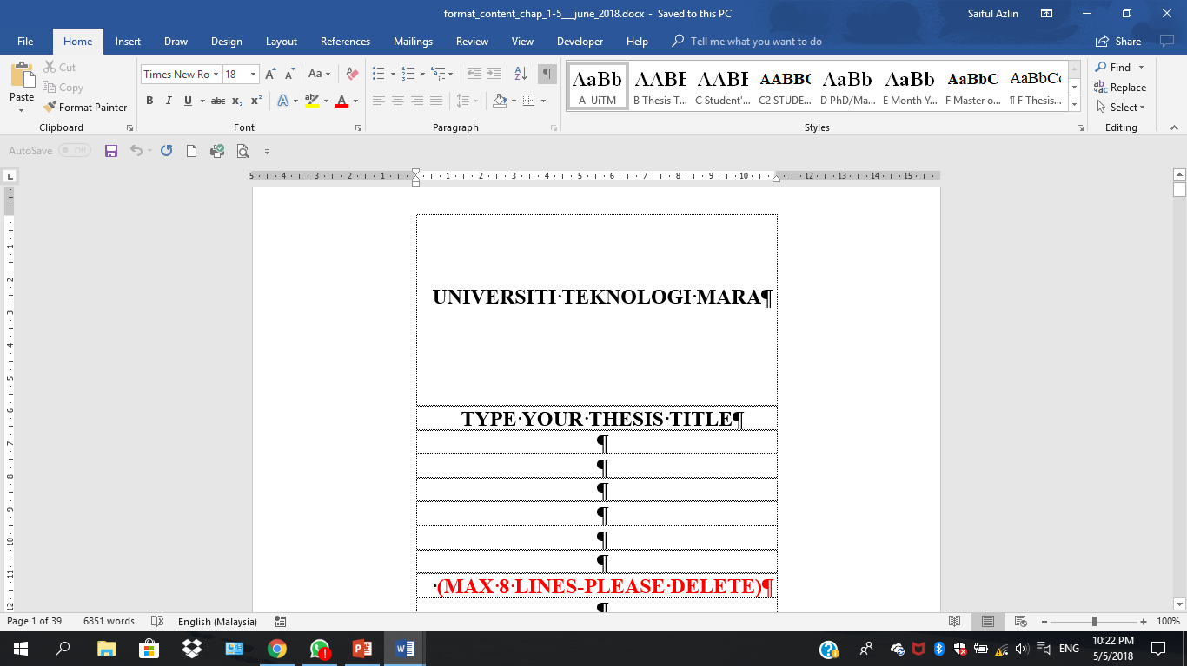
Paragraph marks unticked

