FORMATTING MARGIN
Find Layout & click arrow at bottom right corner of Page Setup
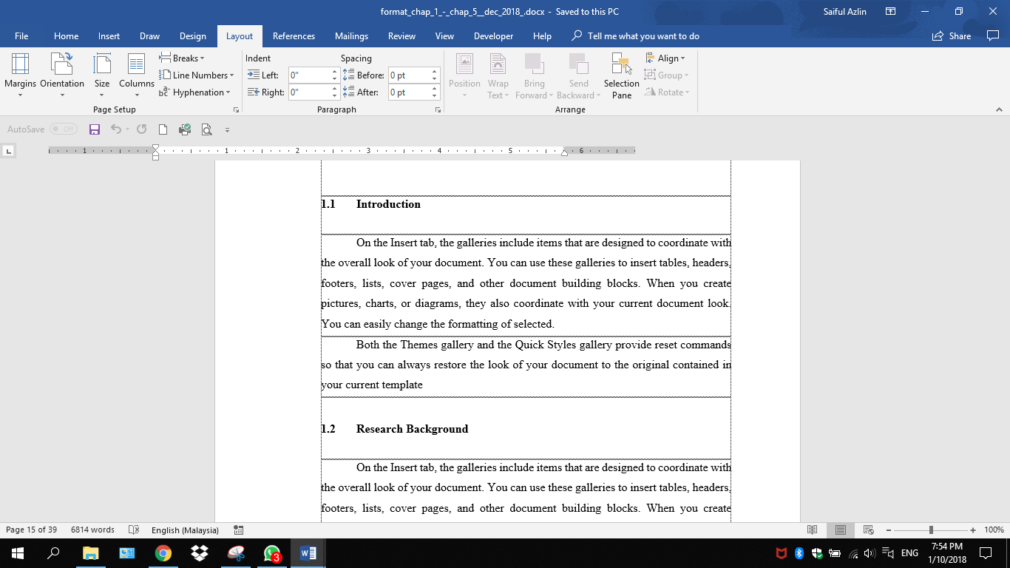
If in inches
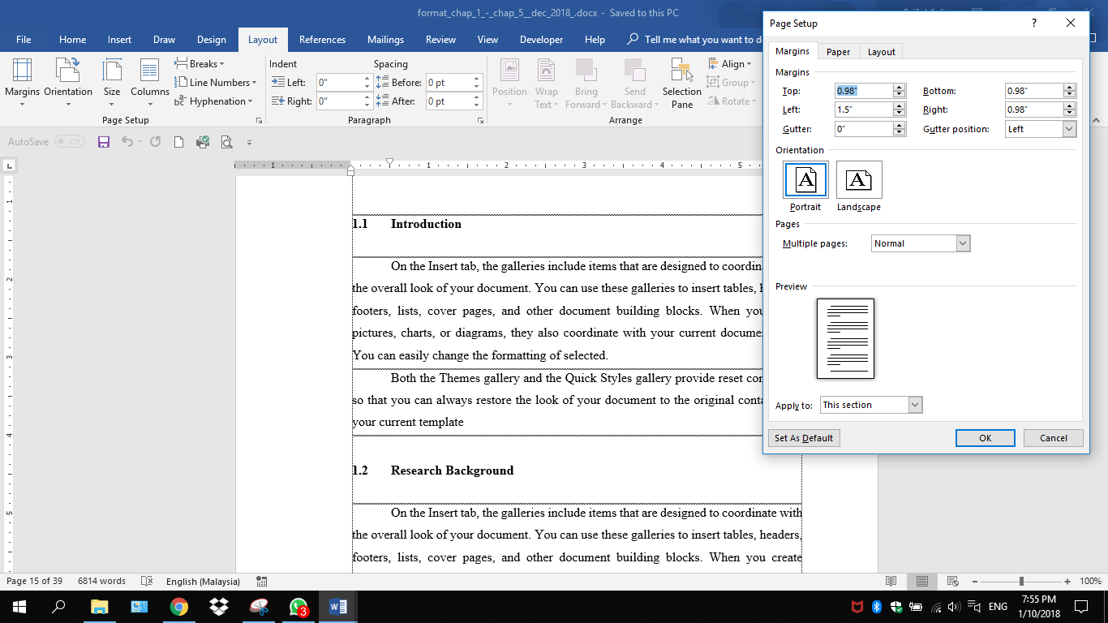

May check whether your margin was set up by inches or centimeters
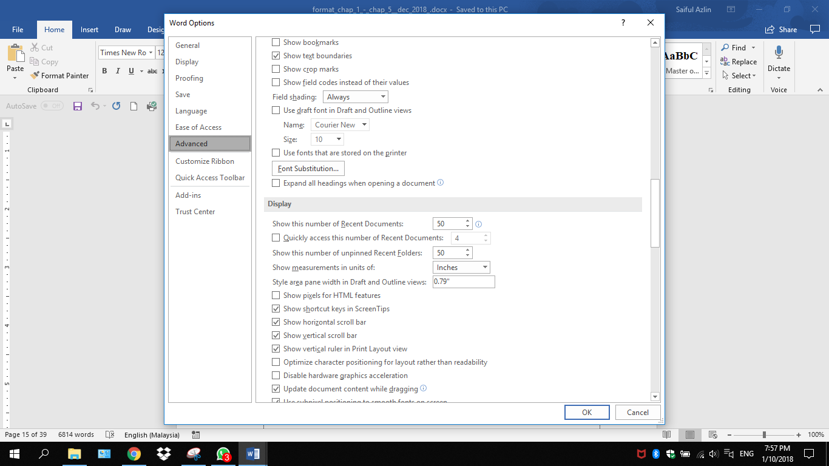

If in centimeters
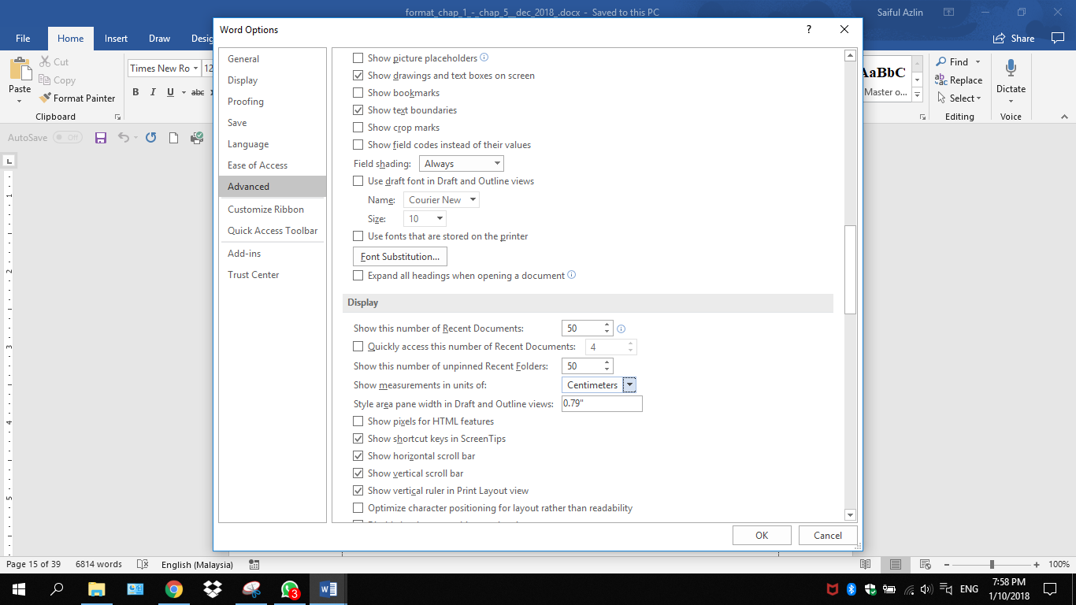
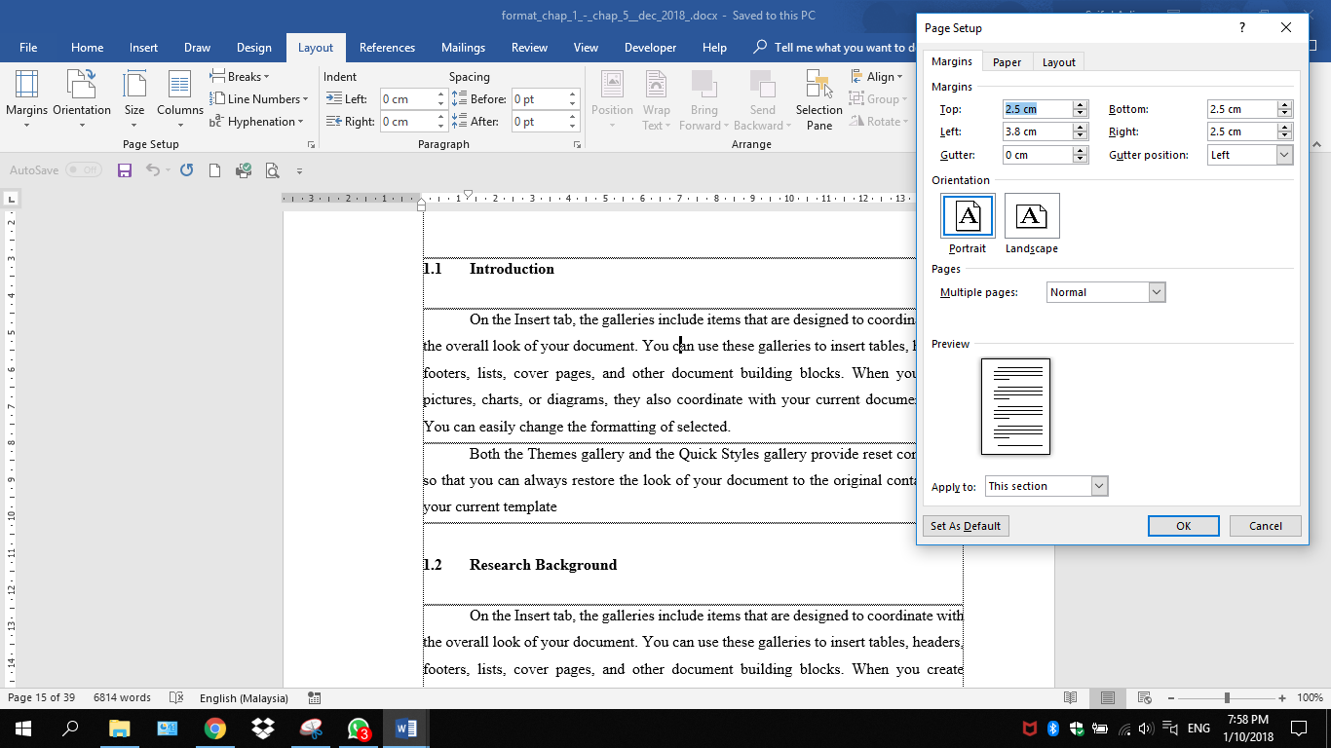
FORMATTING STYLE WITHIN PARAGRAPH
Open Word document & click File

Click Options
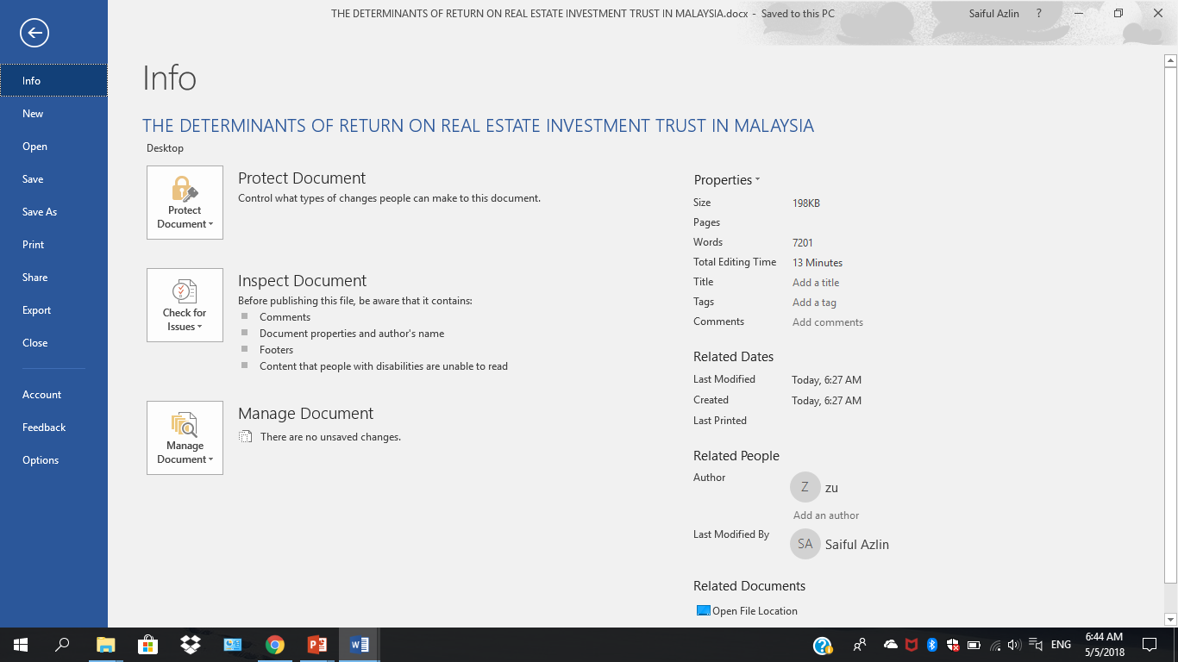

Word Options
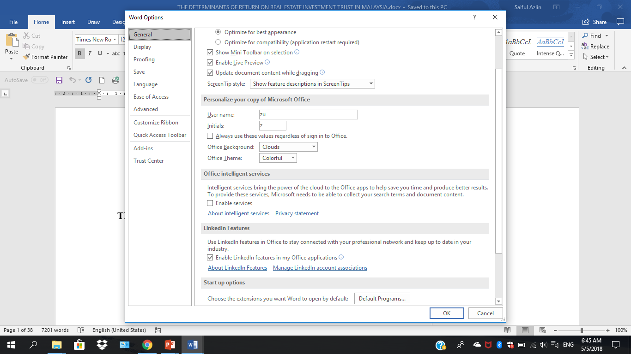

Choose Customize Ribbon
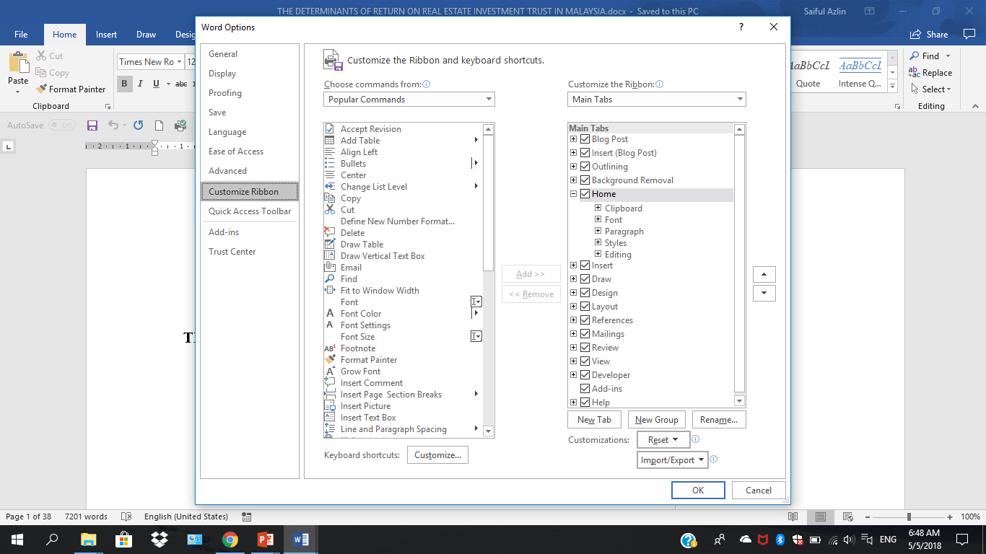
Tick Developer

Without Developer
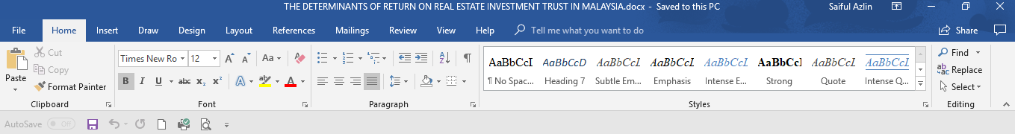
With Developer
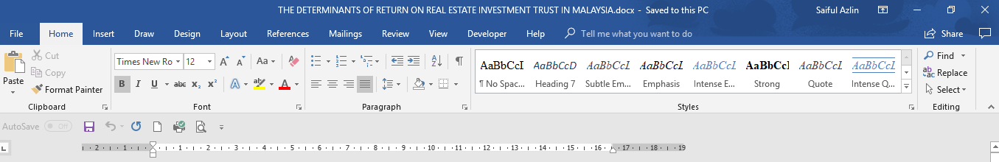

Open your document
Choose Developer & click Document Template

Document Template
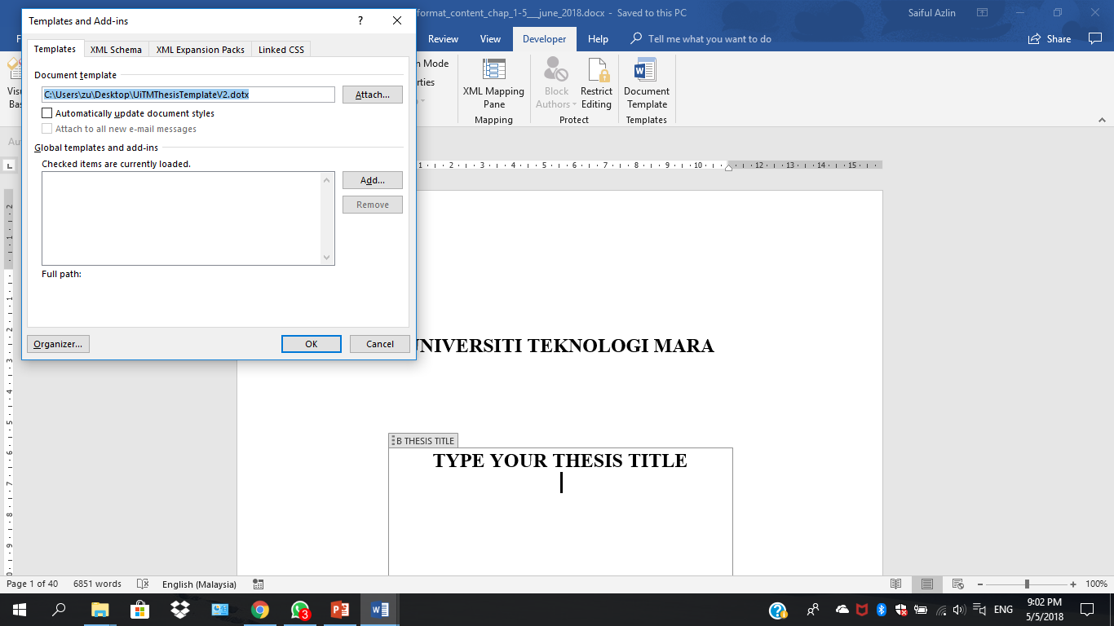

Click Attach—UiTMThesisTemplateV2 and tick Automatically update document style
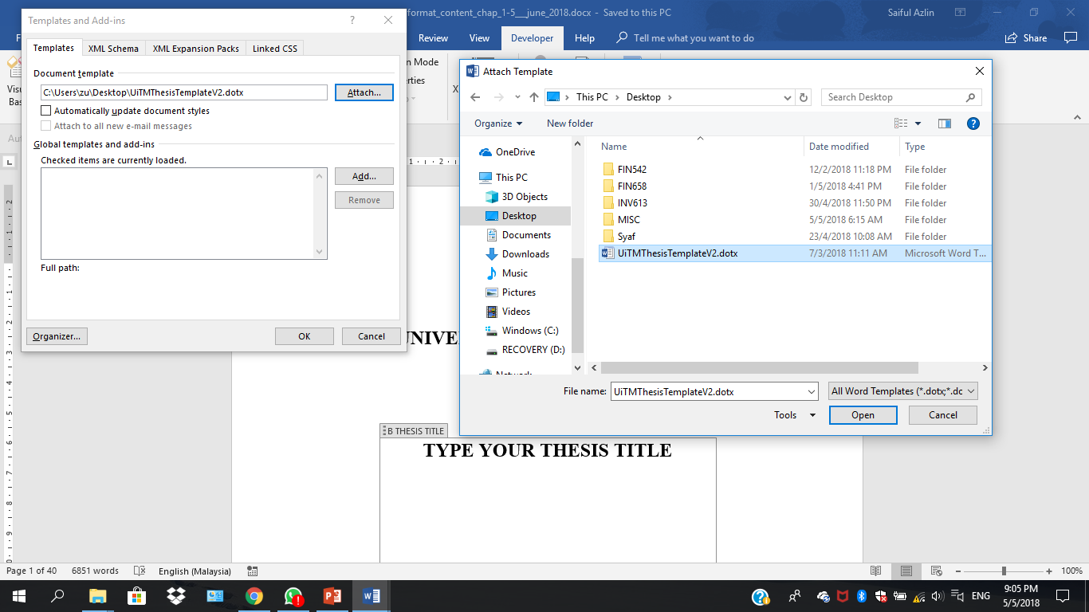

Go Home and click on the arrow at the bottom corner right of Styles

Put the cursor in the middle of the paragraph and choose the appropriate style according to the format given in the blog
Before reformatting

After reformatting thesis title
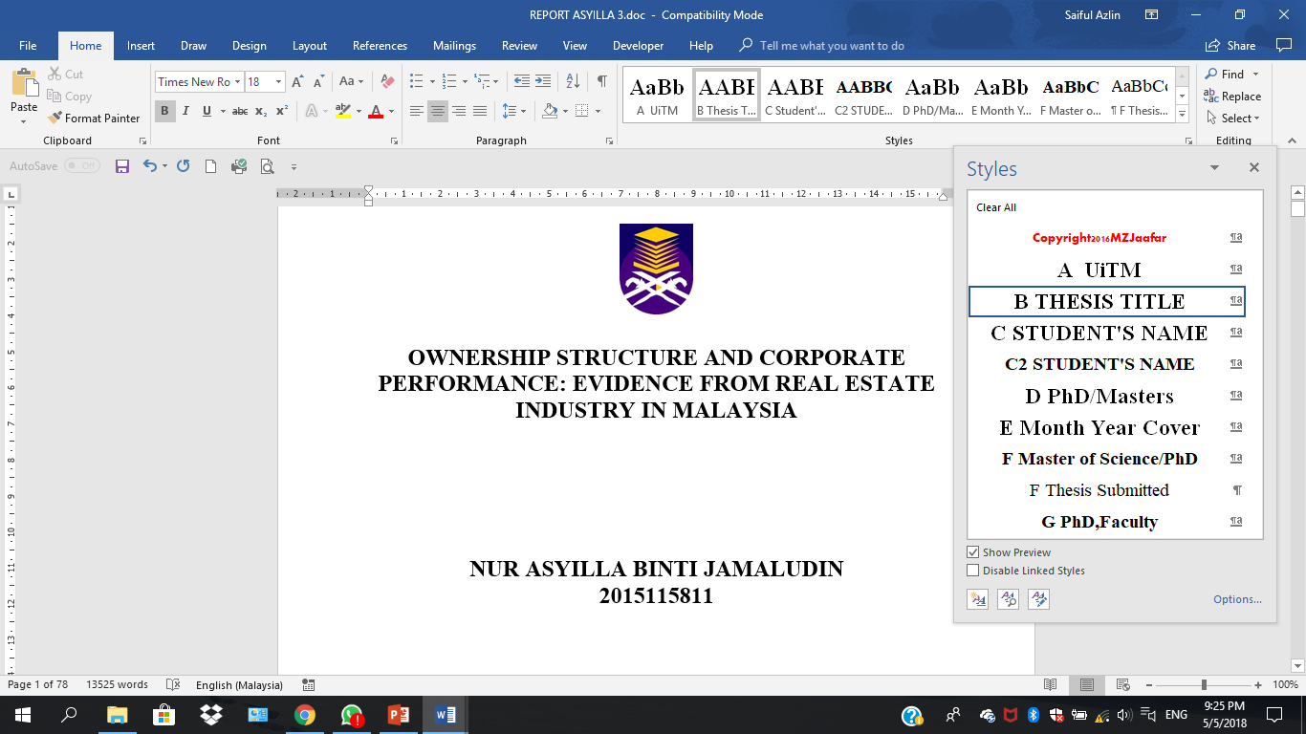

After reformatting Student’s Name
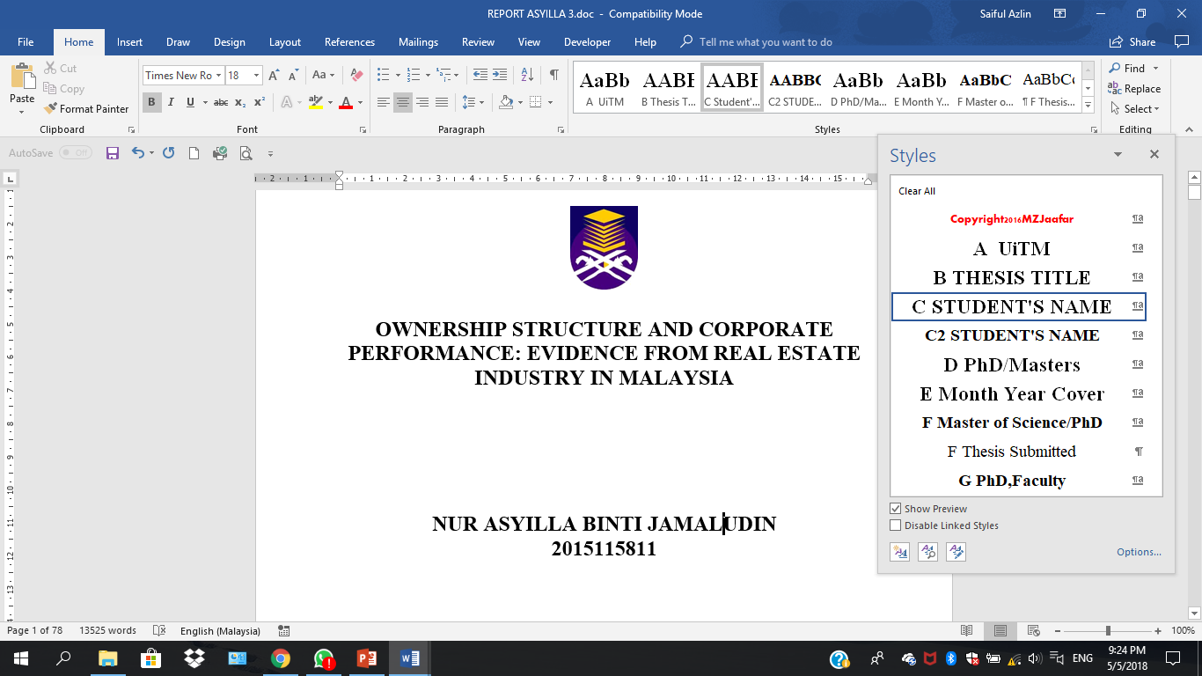

Before reformatting sub-title and paragraph

After reformatting sub-title and paragraph

May also ‘clear all formatting’ and click on respective style
After clear all formatting

Table before formatting
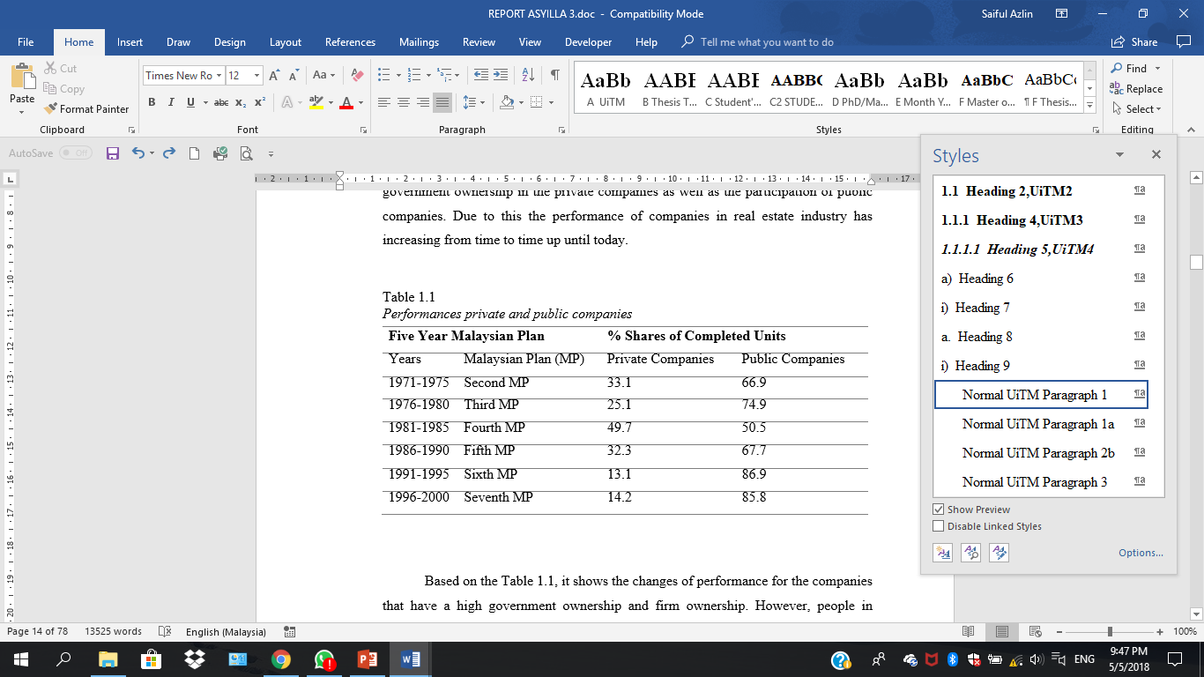

Table after formatting
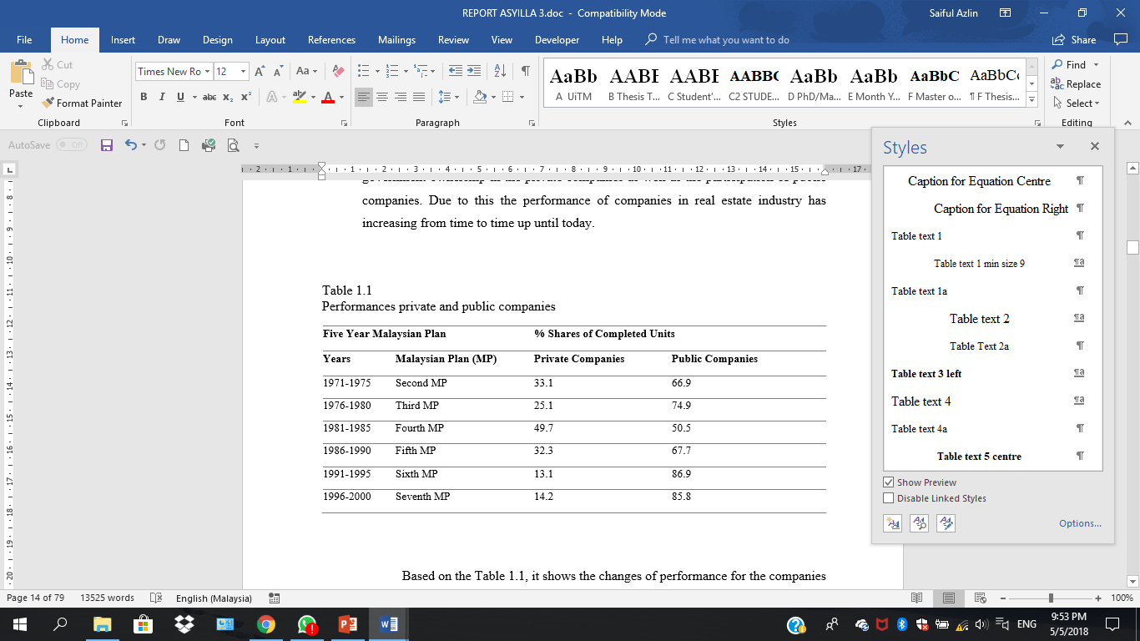
- For each title, sub-title, paragraph, table etc, use and repeat the same format as per format given.
- DO NOT type the numbering manually. Use ‘clear format’ and choose the format given. For each level of numbering, the numbering will automatically continue from previous.

FORMATTING SPACE BETWEEN PARAGRAPH
Using text boundaries: Click File and choose Option

Click Advanced
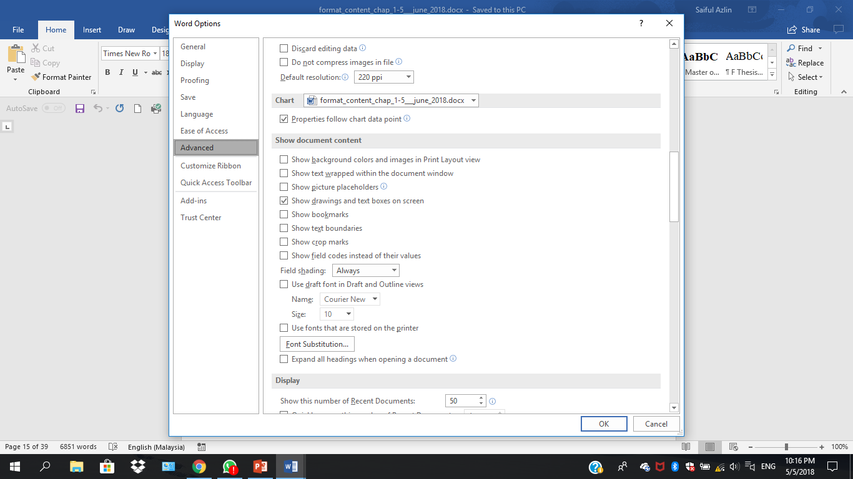
Find show document content and tick show text boundaries

Text boundaries was unticked

Text boundaries was ticked
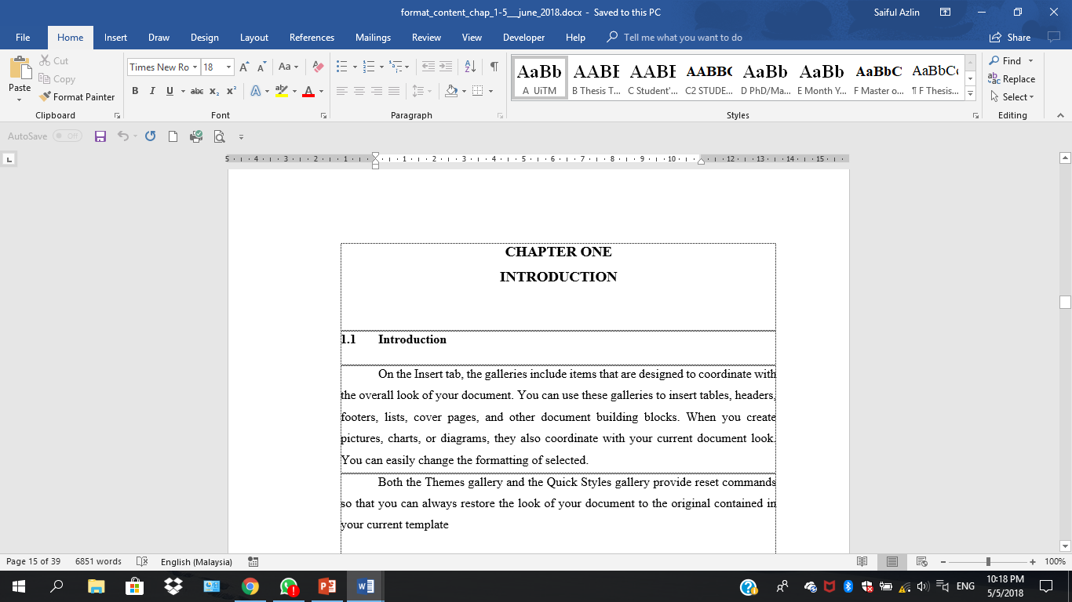
By using text boundaries, you’ll see clearly margin and spacing of your paragraphs

May also use paragraph marks
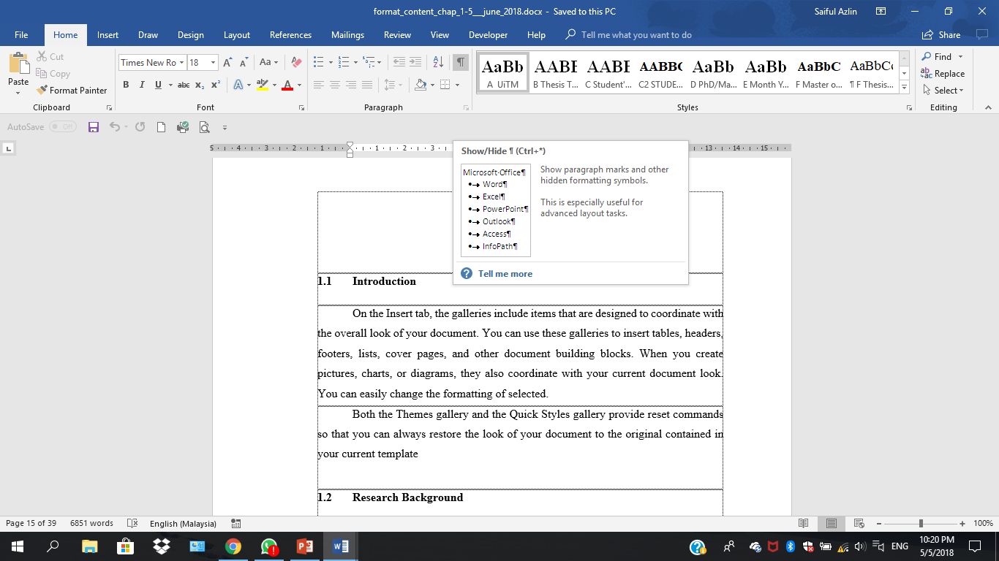

Paragraph marks unticked

Paragraph marks was ticked
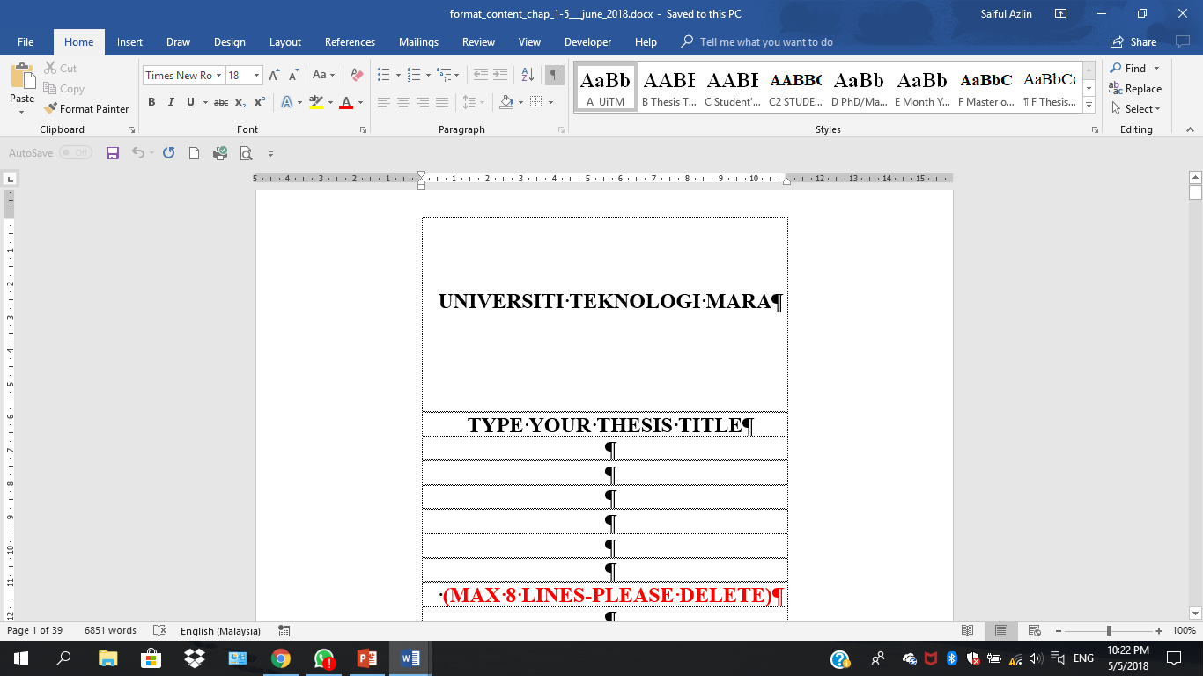

By using paragraph marks, you’ll be able to identify how many times have you pressed ‘enter’

UPDATE LIST
Put cursor within the highlighted area and right click
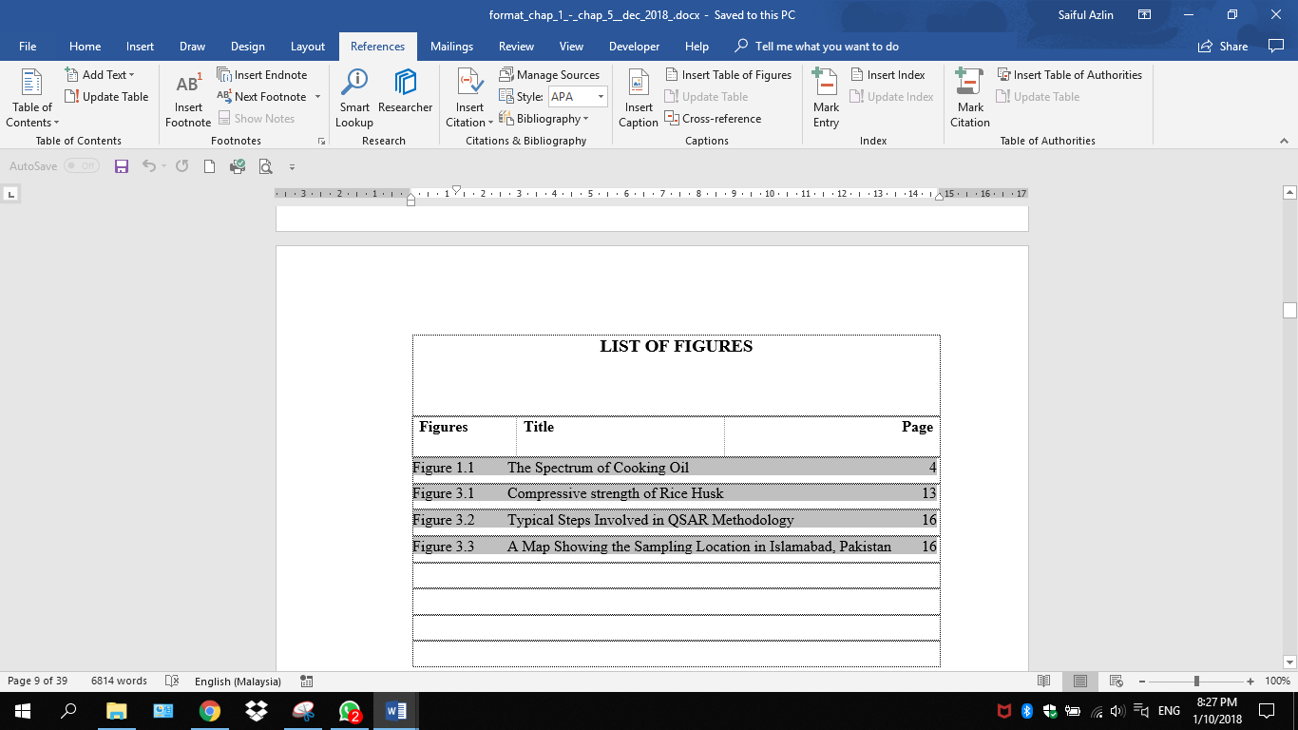
Click Update Field
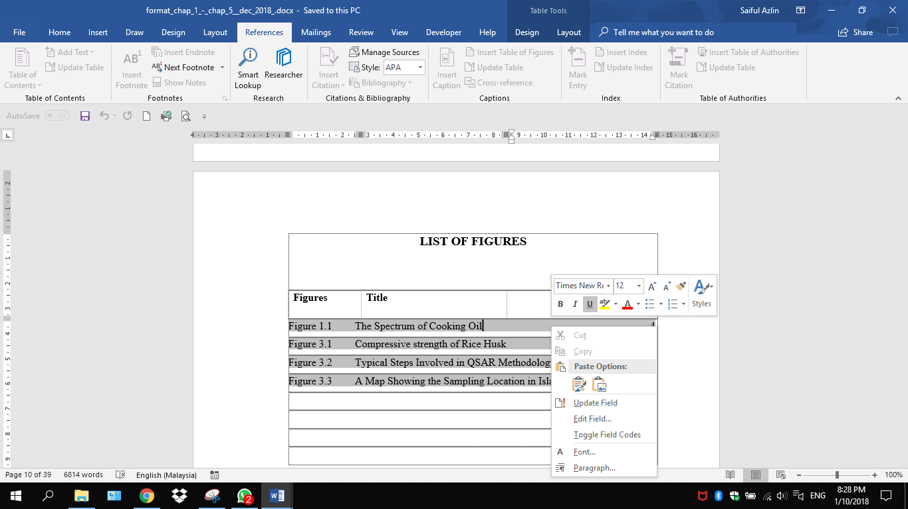

May choose either update page numbers only (will update page number only) OR update entire table (will update numbering, title and page number)
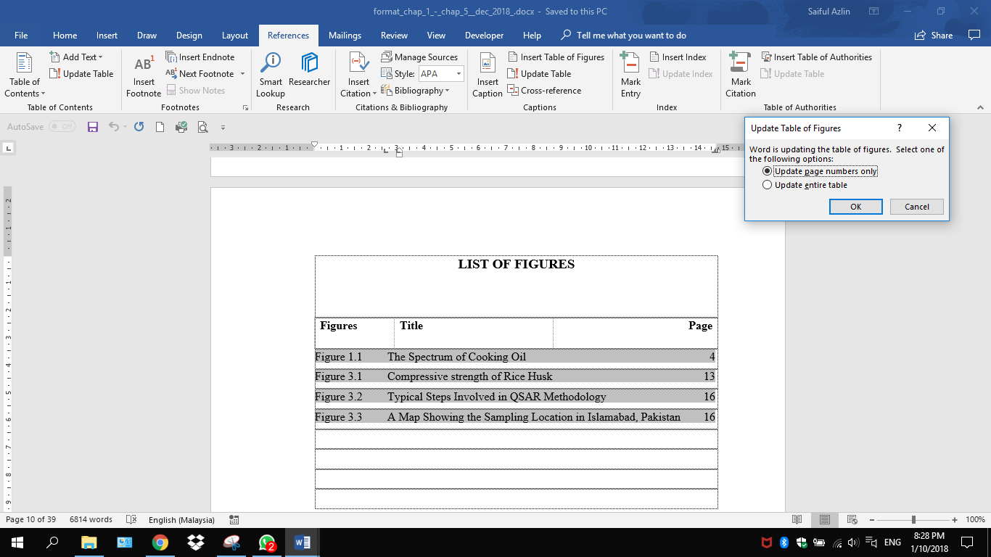

“Put your heart, mind and soul into even your smallest acts. This is the secret of success.”
-Swami Sivananda-

